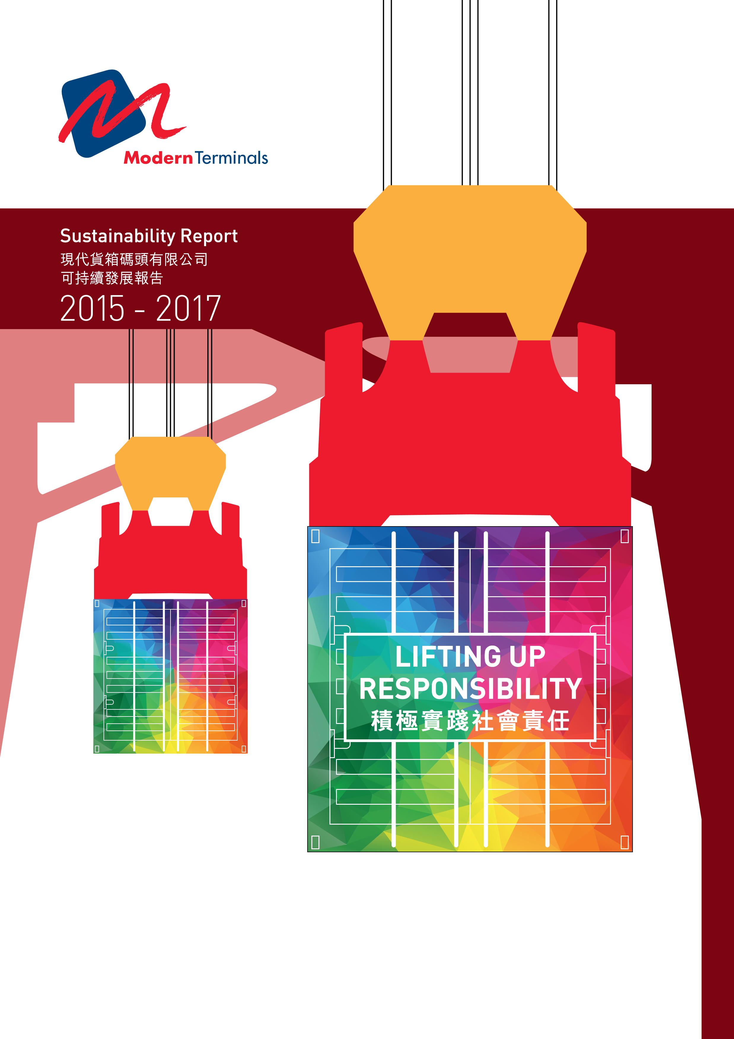

CONTENTS
目錄

3 About the Report
關於本報告

4 Message from Group Managing Director
集團董事總經理獻辭

6 About Modern Terminals Limited
關於現代貨箱碼頭有限公司

10 Engaging with Stakeholders
與持份者溝通

16 Corporate Governance
企業管治

20 Our People
以人為本

30 Health and Safety
健康及安全

36 Environment
環境

42 Community Involvement
社區參與

48 Performance Statistics
統計數據摘要

54 GRI G4 Content Index
全球報告倡議組織（GRI）G4內容索引

58 Assurance Statement
核實聲明

ABOUT THE REPORT

關於本報告

This is the third standalone sustainability report of Modern Terminals Limited (the Company), in which we continue to disclose our achievements and challenges along our sustainability journey. This year, the name of report has been changed from Corporate Social Responsibility Report to Sustainability Report to describe better our ongoing efforts on material aspects along the journey.

This report was prepared in accordance with the Global Reporting Initiative (GRI) G4 Sustainability Reporting Guidelines (“Core” option). The reporting period covers the 30-month period from 1 July 2015 to 31 December 2017, and we aim to report every two calendar years starting with our 2018 - 2019 report. To determine the topics to be disclosed in this report, we engaged with a selected group of stakeholders through an independently-managed engagement and materiality assessment process to understand their key concerns.

The coverage of this report includes our operations in Hong Kong and DaChan Bay in western Shenzhen, which we have majority holding of shares. Taicang International Gateway was not included in this report due to change in shareholding.

This report has been independently verified by the Hong Kong Productivity Council in accordance with the “Core” option of the GRI G4 Guidelines. The assurance statement can be found at the end of this report.

這是現代貨箱碼頭有限公司（公司）發表的第三份獨立成刊的《可持續發展報告》，內容繼續涵蓋我們在可持續發展旅途中取得的成果和面對的挑戰。今年，報告名稱由《企業社會責任報告》更改為《可持續發展報告》，更適切地描述我們於可持續發展旅程中在各重要範疇的持續工作。

本報告是根據「全球報告倡議組織」（GRI）可持續發展報告指南G4版本（核心選項）撰寫，報告期為2015年7月1日至2017年12月31日，我們的目標是從2018-2019年的報告開始，每兩日曆年發表一次報告。為了準備本報告和釐定報告的內容範圍，我們與選定的持份者群組溝通交流，聽取他們對集團營運的關注，然後進行重要性評估以辨識重要議題。

本《可持續發展報告》涵蓋範圍包括香港業務及我們持有大份額股權，位於深圳西的大鏟灣碼頭的業務。太倉國際門戶因股權變動而未納入本報告涵蓋範圍。

本報告已交由香港生產力促進局按照GRI G4報告指南的核心選項進行獨立第三方審核。有關詳情，請參閱報告結尾部份的核實聲明。

MESSAGE FROM GROUP MANAGING DIRECTOR
集團董事總經理獻辭

At Modern Terminals, we are committed to sustainability which is reflected in our Vision and Mission. We aim to be a sustainable enterprise bringing sustainable development of local economies and improvement to people’s well-being. In 2008, with an aim to enhance further our efforts in sustainability, we established our CSR Policy. As we move into 2018, I am proud to see the achievements we have made in the last ten years. In 2017, we reviewed our Policy and added corporate governance as one of our key components to reflect its importance. We also updated the part on community involvement to incorporate the results from the recent strategic review of our focus areas.

There have been a number of disruptions to our industry in the last few years and among the many challenges we have been facing are uncertainties in the global economy, restructuring of carrier alliances, continuous consolidation of shipping lines, competition from nearby ports, deployment of more mega container vessels, and labour supply. Our business is no longer cyclical and this challenging business environment is the “new normal” for our industry. In 2017, the global container trade was strong after two years of low growth. However, we expect to see a moderate “new normal” growth in the coming year.

At Modern Terminals, we are well-equipped and positioned to face all these challenges. We are upgrading our infrastructure in Hong Kong, enhancing our productivity and efficiency in all our facilities, and gearing up our capability in innovation, cyber security, and use of big data.

現代貨箱碼頭致力推動可持續發展，我們的承諾已彰顯於公司的願景和使命。我們的目標是成為一個可持續發展的企業，為當地經濟帶來持續發展，造福社群。為了進一步提升可持續發展的工作，我們於2008年制定企業社會責任政策。邁向2018 年，公司在過去十年取得的成就令我感到自豪。我們於2017年就可持續發展政策作審視時，新增了「企業管治」為可持續發展的範疇之一，以反映其重要性。與此同時，「社區參與」範疇也因應策略審視結果更新的焦點作出調整。

過去幾年，我們的行業有著各種不同的變化及面對不少的挑戰，包括全球經濟的不明朗、航運聯盟重組、船公司的不斷整合、附近港口的競爭、更多大型貨箱船投入服務，以及勞動力供應等。我們的業務不再是周期性的，這個具有挑戰性的商業環境是這行業的「新常態」。全球貨櫃運輸業在經歷兩年低增長後，於2017年增長蓬勃。但我們預期於2018年在「新常態」環境下只會有溫和的增長。

現代貨箱碼頭已作好準備，迎接以上所有挑戰。我們現正優化香港碼頭的基礎設施、積極提升生產力和營運效率，以及加強在創新、網絡安全及大數據使用方面的能力。

We continue to invest in our people and it is a big encouragement for all of us at Modern Terminals to see the significant improvement in various areas across our network in the last two years as reflected in our culture surveys. Ongoing efforts will be put into aligning our culture with our Company Culture Values.

Health and safety is always our top priority and we never compromise it. Despite having a stringent health and safety management process in place, it is with extreme regret for us to report on the fatal accident that took place in Hong Kong in 2016. Though the Labour Department laid no charges against our Company, we conducted an investigation and have applied measures to enhance further our safety management system.

Following our Green Terminal Model, we always take environmental considerations into account in our infrastructure upgrade project and our daily work. The handling of old and new quay cranes in an environmentally friendly manner is one of the many examples. We are also progressing well in achieving our target for emission reduction to 10 kg per TEU by 2018, a 30% reduction from the base year of 2008.

As a result of our strategic review for community involvement, in the years to come we will be supporting youth development, promoting environmental awareness, and promoting sports to lead a healthy life. We have launched our own community initiative and continued our works with our partner school under Project WeCan.

Going forward, we will continue to invest and implement the latest technologies, and work with relevant authorities in Hong Kong to finalize the land rationalization at Kwai Tsing container port to enhance the competitiveness of Hong Kong. We will focus on completing our infrastructure upgrades in Hong Kong and further increasing the productivity and operational efficiencies across our network. We will actively participate in the Greater Bay Area development which is crucial to the future growth of our business. In addition, we will continue our efforts in the five areas of importance to our business namely governance, people, health and safety, environmental protection, and community involvement.

Your feedback is important to our continuous improvement and I invite you to share your comments and suggestions with us.

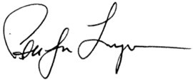
李國維
Peter J. Levesque
Group Managing Director
集團董事總經理
我們繼續投放資源於僱員，文化調查結果顯示，在過去兩年每個業務單位於各個領域均有顯著進步，結果令人鼓舞。我們將繼續培育公司文化，致力將其與企業文化價值觀達成一致。
健康和安全是我們的首要任務，在這個範疇我們從不妥協。縱然已有一套嚴格的健康和安全管理程序，香港業務單位於2016年發生一宗致命意外，令人遺憾。雖然香港勞工處並未就此意外對本公司提出指控，但我們進行了內部審查，並已訂立一系列措施，進一步強化我們的安全管理系統。
根據我們「綠色碼頭模式」的內容，無論基礎設施升級項目或日常工作中均需考慮對環境的影響，以環保的方式處理新及舊岸邊起重機便是許多例子之一。我們在減排方面，目標是在2018年或之前將每個標準箱的排放減到十公斤，較2008年基準年減少30％，現時這方面的工作進展順利。
我們在社區參與方面進行了策略審視，公司將於未來聚焦支持青少年發展、提高環保意識及提倡多做運動帶來健康生活。我們已推出由公司主辦的社區活動，並繼續與夥伴學校合作推動「學校起動」計劃。
展望未來，我們會繼續投資及採用最新科技，並與香港有關當局合作，完成善用葵青貨櫃港周邊土地的安排，以提升香港的競爭力。我們將專注完成香港的基礎設施優化工作，以及進一步提升公司旗下碼頭的生產力和營運效率。公司將積極參與對未來業務增長非常重要的大灣區發展。此外，我們會繼續於以下五個重要領域努力，即企業管治、以人為本、健康及安全、環境保護、和社區參與。
閣下的反饋對我們的持續進步非常重要，歡迎提供寶貴意見和建議。

ABOUT MODERN TERMINALS LIMITED
關於現代貨箱碼頭有限公司

Modern Terminals Limited is a privately-owned company with a shareholder portfolio of regional industry leaders, namely The Wharf (Holdings) Limited (68%), China Merchants Port Holdings Company Limited (27%) and Jebsen Securities Limited (5%). Headquartered in Hong Kong, we own and operate container terminals at Kwai Tsing Container Port, Hong Kong. In the Pearl River Delta, we operate and hold a majority interest in DaChan Bay Terminals and also hold equity stakes in both Shekou Container Terminals and Chiwan Container Terminal. The business activities of the Company include container terminals operation and warehousing activities.

Our customers are shipping lines and primary suppliers are in the areas of terminal equipment and facilities, information technology services, general office equipment, and operations such as internal trucking.
現代貨箱碼頭有限公司是一家私營企業，股東均為業內翹楚，包括九龍倉集團有限公司（68%）、招商局港口控股有限公司（27%）和Jebsen Securities Limited （5%）。公司以香港為總部，在香港葵青港擁有及營運貨箱碼頭，並為珠江三角洲（珠三角） 大鏟灣碼頭的主要股東及營運商。現代貨箱碼頭亦持有珠三角蛇口集裝箱碼頭及赤灣集裝箱碼頭股權。公司業務包括貨箱碼頭營運和貨倉租賃。

我們的客戶為船公司，主要供應商涵蓋的範圍包括碼頭設備及設施、資訊科技服務、一般辦公室設備，以及碼頭營運服務如內運拖車等。

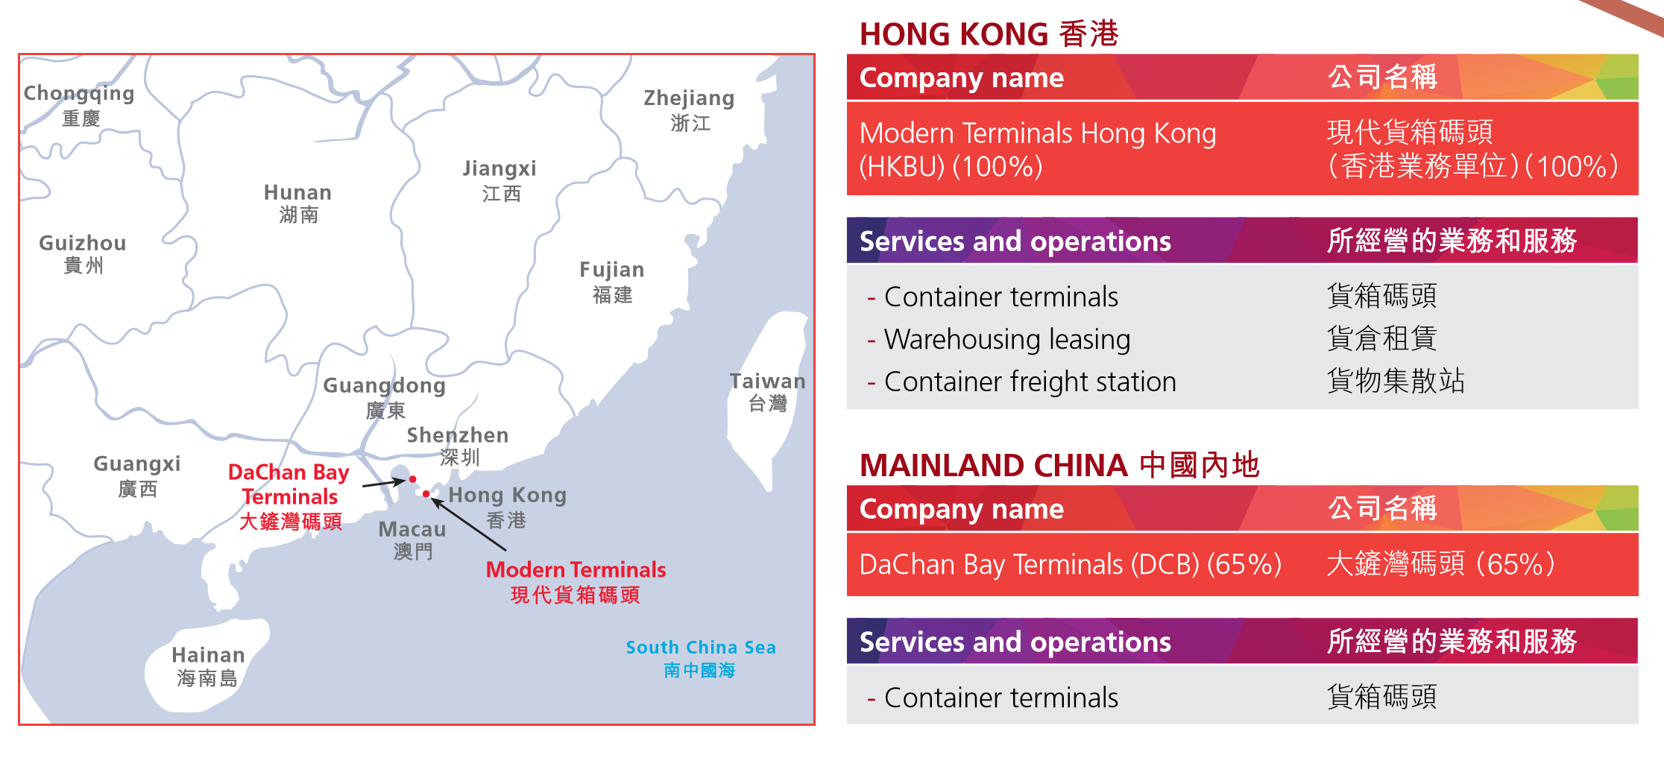
MAJOR MEMBERSHIPS AND CHARTERS
主要會籍和約章
HONG KONG 香港
American Chamber of Commerce (Corporate Representative,  Ex-Officio Governor)  香港美國總商會（公司代表、當然董事） | Federation of Hong Kong Industries – Transport and Logistics Services Council / PRD Council (Corporate Member)  香港工業總會—運輸及物流業協會和珠三角工業協會（公司會員）
Business Environment Council (Council Member)  商界環保協會（理事會成員） | General Stevedoring Council (Member) （會員）
The Chartered Institute of Logistics and Transport  in Hong Kong (Corporate Member)  香港運輸物流學會（公司會員） | Hong Kong Container Terminal Operators Association Limited (Committee Member and Treasurer)  香港貨櫃碼頭商會有限公司（委員會成員和司庫）
Clean Air Charter led by Business Coalition on the Environment (Endorser)  由商界聯盟牽頭的《清新空氣約章》（承諾公司） | Hong Kong General Chamber of Commerce (Corporate Member)  香港總商會（公司會員）
Danish Chamber of Commerce (Corporate Member)  丹麥商會（公司會員） | Hong Kong Logistics Management Staff Association (Member)  香港物流管理人員協會（會員）
Employers’ Federation of Hong Kong (Corporate Member)  香港僱主聯合會（公司會員） | Hong Kong Management Association (Corporate Member)  香港管理專業協會（公司會員）
Energy Saving Charter and 4Ts Charter by The Environment Bureau of HKSAR Government (Participant)  由香港特別行政區政府環境局推出的節能約章計劃及4Ts 約章計劃（參與公司） | Hong Kong – United States Business Council (Member) （會員）
TT Club (Board Member)
聯運保賠協會（董事會成員）
World Wide Fund for Nature Hong Kong (Silver Member)
世界自然基金會（純銀會員）
DACHAN BAY 大鏟灣
Shenzhen Ports Association (Vice Chairman Unit)  深圳港口協會（副會長單位） | China Ports Association Container Branch (Member)  中國港口協會港口集裝箱分會（會員）
Shenzhen Association of Enterprises with Foreign Investment (Governing Unit)
深圳外商投資企業協會（常務理事單位）

AWARDS AND RECOGNITIONS
獎項和嘉許

HONG KONG 香港
Organizer  主辦單位 | Award and recognition  獎項和嘉許 | Year of award  獲嘉許年份
Hong Kong Council of Social Service  香港社會服務聯會 | Caring Company Logo  「 商界展關懷」標誌  10 Years Plus Caring Company Logo  連續十年 或以上「商界展關懷」標誌 | Since 2007  自2007年  2017  2017年
Lloyd’s Register Quality Assurance Ltd. | ISO14001 EMS Certification  ISO14001環境管理體系認證 | Since 2009  自2009年
Office of Government Chief Information Officer and  Equal Opportunities Commission  政府資訊科技總監辦公室及平等機會委員會 | Silver Award - Website Stream,  Web Accessibility Recognition Scheme  無障礙網頁嘉許計劃銀獎  （網站組別） | 2015 and 2016  2015年及2016年
Employees Retraining Board  僱員再培訓局 | Manpower Developer  人才企業嘉許計劃 | Since 2014  自2014年
Mandatory Provident Fund Schemes Authority  強制性公積金計劃管理局 | Good MPF Employer Award  「 積金好僱主」標誌 | 2016 and 2017  2016年及2017年
Hong Kong Productivity Council and the Promoting Happiness Index Foundation  香港生產力促進局及香港提升快樂指數基金 | Happy Company  「 開心企業」標誌 | 2017  2017年
Business Environment Council  商界環保協會 | Sustainable Consumption Enterprise  支持可持續消費行為企業 | 2017  2017年

SGS | ISO14001 EMS Certification  ISO14001環境管理體系認證 | Since 2013  自2013年
China Association of Enterprises with Foreign Investment and Shenzhen Association of Enterprises with Foreign Investment  中國外商投資企業協會及深圳外商投資企業協會 | National Excellent Enterprise with Foreign Investment Harmonious Labour Relationship Promotion (2015-2016) and National Excellent Enterprise with Foreign Investment Excellent Tax Payment and Turnover (2015-2016)  全國優秀外商投資企業和諧勞動關係  促進獎（2015-2016年度）  全國優秀外商投資企業雙優企業獎（2015-2016年度） | 2015 and 2016  2015年及2016年
China (Shenzhen) International Logistics and Transportation Fair Organizing Committee  中國(深圳)國際物流與交通運輸博覽會組委會 | Innovative Enterprise Award  創新企業獎 | 2016  2016年
12th China Freight Industry Awards 2016 (CFIA)  第十二屆中國貨運業大獎評審委員會 | Silver Award - Green Container Terminals  集裝箱碼頭綠色低碳銀獎 | 2016  2016年
Navis and Port Technology International  Navis及Port Technology International | Award of Recognition – Terminal Operations Optimization  優化碼頭業務運作獎 | 2017  2017年
China Shipping Gazette and 2017 China Freight Industry Award Committee  中國航務週刊雜誌社及2017中國貨運業大獎組委會 | Top 10 Container Terminals for Good Services and Gold Medal for Green Terminals  綜合服務十佳集裝箱碼頭獎及集裝箱碼頭綠色低碳金獎 | 2017  2017年

ENGAGING WITH STAKEHOLDERS
與持份者溝通

Our Company has always engaged with our stakeholders through various channels to communicate on different issues including business strategies, actions, and sustainability efforts. We used a comprehensive mapping and prioritization process to identify stakeholders to engage, based on their influence or dependency on the Company. For the preparation of this report, we conducted interviews with selected customers – one of the most important stakeholder groups identified from the stakeholder mapping process. Previously, we have conducted focus groups and interviews with various stakeholder groups including selected representatives of our customers, employees, contractors and suppliers, and industry associations for our first report; and for our last report our employees and shareholders. For details, please refer to our previous reports.

公司定期與持份者透過各種渠道溝通，訊息包括公司業務策略和工作，以及於可持續發展工作方面的努力。我們根據持份者對公司的影響力或對公司的依賴程度進行量化評估和確立優先次序。在準備此報告時，我們對選定的客戶進行了面談。根據持份者量化評估的結果，客戶是我們選定最重要的持份者組別之一。在此之前，我們在準備第一份報告時進行了多個持份者小組座談會和面談，包括客戶、僱員、承辦商、供應商，以及行業商會的代表；於上一份報告，我們邀請了股東和僱員代表進行小組座談會和面談。詳情請參閱相關報告。

The diagram below shows the stakeholder groups identified with the corresponding engagement channels.
下表列出持份者組別和溝通渠道。

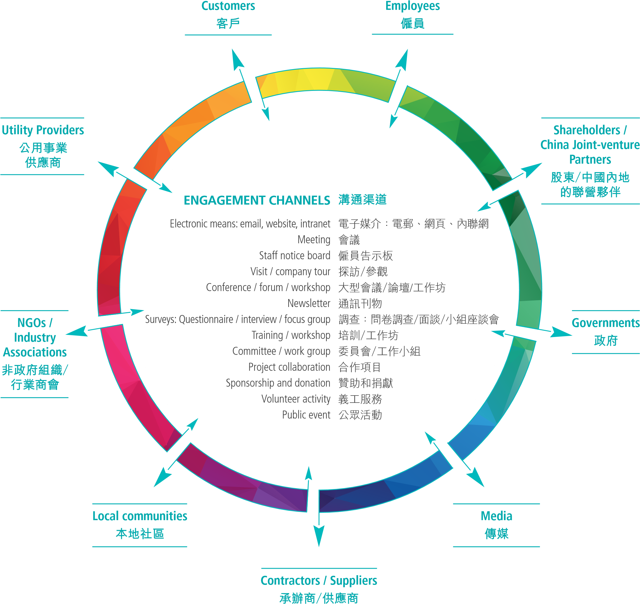

The key issues raised by stakeholders and our responses are presented in the table below.
下表列出持份者提出的重點關注議題和我們的回應：
Key issues raised by stakeholders engaged  持份者提出重點關注議題 | Our response  我們的回應

Sustainability performance and communications 於可持續發展範疇的表現和溝通
Diversified channels to communicate the Company’s sustainability efforts with different stakeholders  透過不同渠道與持份者溝通有關公司在可持續發展方面的工作 | In addition to the Sustainability Report, we are making use of various channels including website to share information on our sustainability efforts. Since 2016, we have posted details of our efforts and achievements on social media platform LinkedIn. We will continue to incorporate such information in communications with our stakeholders.  除了《可持續發展報告》外，我們同時使用不同渠道與持份者分享公司在可持續發展方面的資訊，包括公司網站。自2016年，我們亦在社交媒體平台LinkedIn發佈公司在可持續發展方面的努力和成果。我們將繼續與持份者就相關資訊溝通。
Disclosure of the Company’s strategy for maintaining its competitiveness, especially in Hong Kong, in the face of a challenging and changing business environment  面對充滿挑戰和變化的商業環境，披露公司維持競爭力的策略，特別是香港的業務 | We are fully aware of the continuing challenges our industry faces. The Company is well-equipped and positioned to continue operating in this new environment. Through the Hong Kong Container Terminal Operators Association (HKCTOA), we have raised issues with the HKSAR Government and have been working closely with all industry stakeholders to enhance the competitiveness of the port of Hong Kong as a whole.  We have also made significant investments in upgrading our infrastructure and equipment. We have also been working on several initiatives that use technology to enhance our productivity and operational efficiency.  我們充分了解行業持續面對各項挑戰，公司已作好準備，確保在新的環境中繼續營運。我們透過香港貨櫃碼頭商會向香港特區政府提出各項議題；與此同時，我們與所有行業持份者緊密合作，為提升香港港口的整體競爭力而努力。  我們已作出重大的投資，提升基礎設施和設備，並一直進行各個項目，透過科技提高生產力和營運效率。
Environmental performance 環保表現
Use of green energy at terminal operations  於碼頭營運採用綠色能源 | The main types of equipment at terminals are quay cranes (QCs) and rubber-tyred gantry cranes (RTGs). QCs are powered by electricity. We converted all RTGs in Hong Kong to electricity-powered RTGs (E-RTGs) by the end of 2014; DCB has used a full fleet of E-RTGs since it commenced operations in 2007.  In DCB, we have installed shore power and are using LNG tractors for internal trucking.  We spare no effort in turning our Green Terminal Model¹ into a reality and will continue to reduce our emissions and energy consumption. In recent years, we have been exploring the possibility of using electric tractors for internal trucking in Hong Kong.  碼頭的主要設備包括岸邊起重機和膠輪式龍門起重機。岸邊起重機一向由電力驅動，而所有位於香港的膠輪式龍門起重機已於2014年底改裝為電力驅動。大鏟灣碼頭自 2007年開始營運以來，一直使用電力驅動的膠輪式龍門起重機。  在大鏟灣碼頭，我們安裝了岸電及使用液化天然氣拖車處理貨箱內運工作。  公司致力實踐我們的綠色碼頭模式¹，推動環保工作，並將繼續減少氣體排放和能源消耗。近年來，我們一直研究於香港的碼頭堆場內使用電動拖頭的可行性。  For details, see page 31 of our 2013-15 CSR Report.  詳情請參閱我們的企業社會責任報告2013-15，第31頁。
Key issues raised by stakeholders engaged  持份者提出重點關注議題 | Our response  我們的回應
People以人為本
Management of contractors and suppliers  承辦商和供應商管理 | Contractor and subcontractor management is an integral part of our daily operations. We require all our contractors and subcontractors to comply with local laws, and hold our contractors’ and subcontractors’ workers to the same strict health and safety standards we set for our staff.  We will launch our Code of Conduct for Suppliers in 2018 to strengthen supplier management.  管理承辦商和分包商是我們日常營運的重要一環。所有承辦商和分包商均須遵守當地法律和規例。在健康與安全標準上，我們對僱員、承辦商和分包商職員一視同仁。  我們將於2018年推出供應商行為準則，以加強供應商管理。
Products and services 產品和服務
Deployment of innovation and technology in operations as well as cybersecurity at the Company  創新和科技在公司營運中的應用，以及網絡安全 | At our Company, we embrace innovation which is also part of our brand promises. We collaborate with our customers to drive innovation in the industry to bring benefits to all concerned. Digitalization is the way forward and through HKCTOA our Company, together with other operators, will roll out Electronic Release Order (eRO) for import containers to improve supply chain efficiency and strengthen the competitiveness of the port of Hong Kong. It is expected that an operational eRO system will be fully implemented before December 2019 and terminal operators will target to phase out the current paper-based handling process by 2020.  Cybersecurity is one of the key issues that we are managing. In addition to boosting our hardware and software, staff awareness is also important. For details of our work in this area, please refer to the section on Corporate Governance on page 16.  公司鼓勵創新，亦是品牌承諾之一。我們與客戶協力推動行業創新，為各持份者帶來裨益。電子化是大勢所趨，我們透過香港貨櫃碼頭商會，連同其他營運商將為入口貨箱推出「電子提櫃單」（eRO），以進一步提升供應鏈效率和增強香港港口的競爭力。eRO系統預計將於2019年12月前全面實施，而貨櫃碼頭營運商將於2020年或之前逐步淘汰現在以紙張形式進行的服務。  網絡安全是我們管理的關鍵議題之一。除了提升我們的硬件和軟件外，僱員的意識水平也至關重要。有關我們在這方面的工作細節，請參閱第16頁的企業管治部份。

MATERIALITY ASSESSMENT
During the engagement process, stakeholders were invited to identify key sustainability issues of our Company, and provide feedbacks to our sustainability approach and performance. We also conducted an industry context review to ensure the priorities and boundary are aligned to the industry practices and stakeholders’ expectation. Our material sustainability issues and corresponding boundary are listed in the below table, which was reviewed and approved by our Sustainability Steering Committee.
重要性評估
我們在與持份者溝通的過程中，邀請他們提出其重點關注的可持續發展議題，並為我們在可持續發展的路線和表現提供反饋。我們亦參考同業在這方面的工作，以確保我們的重要議題及範疇的邊界與行業概況看齊和切合持份者的期望。公司的可持續發展指導委員會同意下列範疇和議題對公司至為重要。

No  號碼 | Material Issues  重要議題 | Corresponding GRI G4 Aspects  相關的GRI G4範疇 | Issue Boundary 影響邊界
No  號碼 | Material Issues  重要議題 | Corresponding GRI G4 Aspects  相關的GRI G4範疇 | Within the organization  企業內 | Outside the organization  企業外
No  號碼 | Material Issues  重要議題 | Corresponding GRI G4 Aspects  相關的GRI G4範疇 |  | Contractor/ supplier  承辦商/  供應商 | Customer  客戶 | Community  社區
Economic 經濟
1 | Economic performance  經濟表現 | ECONOMIC: Economic Performance  經濟：經濟表現 | ✓ | ✓
Environment 環境
2 | Climate change  氣候變化 | ENVIRONMENTAL: Energy Consumption  ENVIRONMENTAL: Emissions  環境：能源消耗  環境：氣體排放 | ✓ | ✓ | ✓ | ✓
3 | Emissions/Air pollution  氣體排放/空氣污染 | ENVIRONMENTAL: Emissions  環境：氣體排放 | ✓ |  |  | ✓
4 | Energy consumption  能源消耗 | ENVIRONMENTAL: Energy Consumption  環境：能源消耗 | ✓
5 | Effluents and waste  污水和廢棄物 | ENVIRONMENTAL: Effluents and Waste  環境：污水和廢棄物 | ✓ | ✓ | ✓ | ✓
6 | Environmental compliance  遵守環境法規 | ENVIRONMENTAL: Compliance  環境：遵守法規 | ✓ | ✓ | ✓ | ✓

No  號碼 | Material Issues  重要議題 | Corresponding GRI G4 Aspects  相關的GRI G4範疇 | Issue Boundary 影響邊界
No  號碼 | Material Issues  重要議題 | Corresponding GRI G4 Aspects  相關的GRI G4範疇 | Within the organization  企業內 | Outside the organization  企業外
No  號碼 | Material Issues  重要議題 | Corresponding GRI G4 Aspects  相關的GRI G4範疇 |  | Contractor/ supplier  承辦商/  供應商 | Customer  客戶 | Community  社區
Social 社會
7 | Occupational health and safety  職業健康與安全 | SOCIAL: Occupational Health and Safety  社會：職業健康與安全 | ✓ | ✓
8 | Employee benefits and compensation  僱員福利和薪酬 | SOCIAL: Employment  社會：僱傭關係 | ✓ | ✓
9 | Working conditions and hours  工作環境和時間 | SOCIAL: Labour/ Management Relations  社會：勞資關係 | ✓ | ✓
10 | Employee development  僱員發展 | SOCIAL: Training and Education  社會：培訓與教育 | ✓ | ✓
11 | Contractor’s workers management  承辦商管理 | SOCIAL: Employment  SOCIAL: Occupational Health and Safety  社會：僱傭關係  社會：職業健康與安全 | ✓ | ✓
12 | Community engagement  社區參與 | SOCIAL: Local Communities  社會：本地社區 |  |  |  | ✓
13 | Social compliance  遵守社會法規 | SOCIAL: Compliance  社會：遵守法規 | ✓ | ✓ | ✓ | ✓
Service quality 服務質素
14 | Technology upgrade and operational efficiency  科技提升和操作效率 | ECONOMIC: Economic Performance  經濟：經濟績效 | ✓ |  | ✓
15 | Cybersecurity  網絡安全 | SOCIAL: Cybersecurity  社會：網絡安全 |  |  | ✓

CORPORATE GOVERNANCE
企業管治

We are committed to maintaining a high standard of corporate governance and devote considerable effort to implementing best practices. We believe sound corporate governance is achieved through transparency, fairness, integrity and accountability. To achieve this, we embed governance principles and practices in the business through a well-defined governance structure. A stringent internal control management system is also in place to identify, monitor and mitigate risks.

我們致力維持高水準的企業管治及建立典範實務。我們深信良好的企業管治是要透過恪守公開、公平、誠實正直和負責的最高標準來建立。為此，我們透過明確的管治架構，將管治原則及實務融入日常營運中。公司設立了嚴格的內部監控管理系統，藉此識別存在的風險、進行風險監察和適當地減輕風險。

Modern Terminals Ltd has a simple and effective governance structure with our four-member Management Board overseeing the Company’s development, enhancing shareholder value, and aligning with our Vision and Mission, Strategies, Brand Promises, and Culture Values (details can be found on our Company website).

The Internal Control Steering Committee, comprising department heads of our Company and each business unit is responsible for fostering effective self-monitoring and internal control. All employees of the Company are governed by our Code of Conduct which outlines the Company’s standards and expectations on business ethics. To ensure our high standards are achieved, a whistle blowing policy is in place to encourage anyone with concerns about suspected unethical or unprofessional conduct to come forward and disclose details to senior management. Details are available on our Company website.

現代貨箱碼頭有限公司架構簡潔，由四名成員組成的管理委員會為一簡單而有效的管治架構，負責公司的發展，提升公司對股東的價值，並確保公司發展方向與願景、使命、策略、品牌承諾和文化價值觀一致（詳細資料請瀏覽公司網站）。

內部監控指導委員會由公司及各業務單位的部門主管組成，負責推動有效的自我監察和內部監控的能力。公司的紀律守則列明我們在商業道德方面的要求和期望，所有僱員必須遵守。為確保僱員可達到公司的高要求，我們訂立了舉報政策，鼓勵任何人士如關注某僱員涉嫌違反商業道德或專業行為失當，可向高級管理層舉報，有關政策已詳列於公司網站。

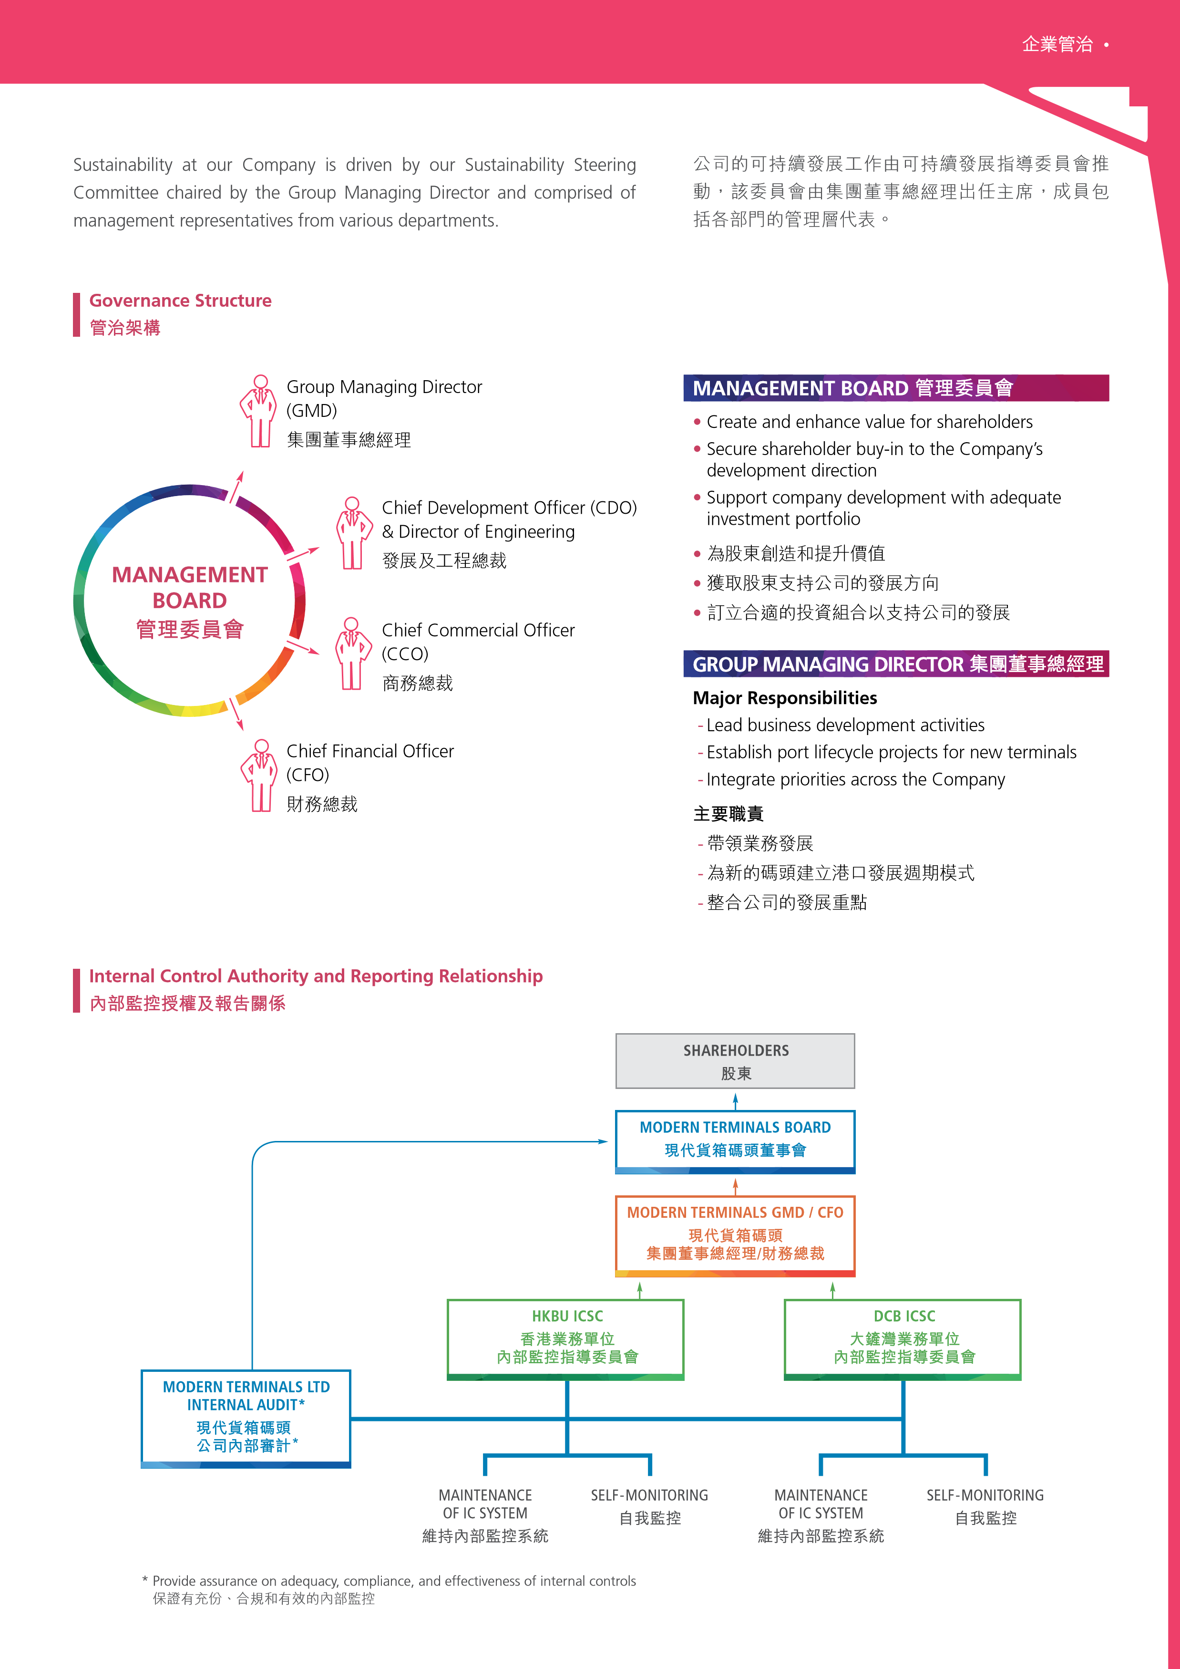
Structure of the Sustainability Steering Committee
可持續發展指導委員會架構
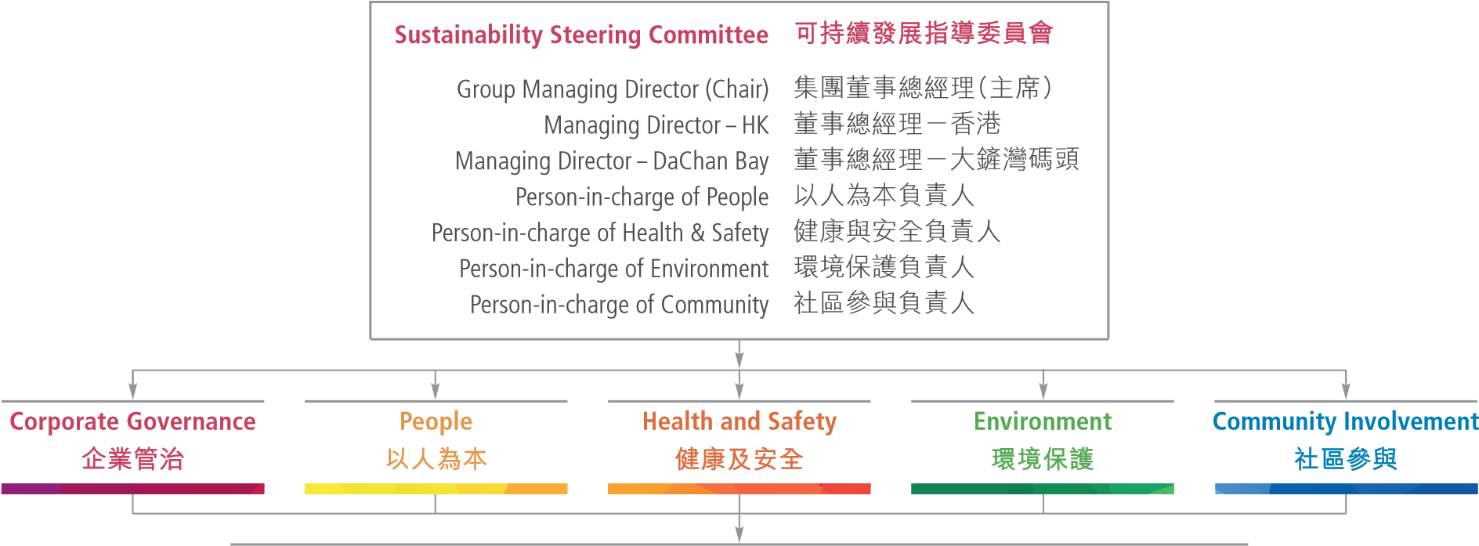
Business Unit Sustainability Committee includes: 業務單位可持續發展委員會成員包括：
- MD /GM • 董事總經理 / 總經理
- Management reps responsible for the five areas • 負責以上五個範疇的管理層代表

UPDATE OF SUSTAINABILITY POLICY
As we continue our sustainability journey, we see the importance of constant review for enhancement. The Sustainability Steering Committee conducted a comprehensive review of our Sustainability Policy in September 2017. Corporate Governance has been added as a key component to reflect the importance we place on this aspect. The section on Community Involvement was revised in line with updates to our focus areas. We will continue managing and reporting on five critical areas: Corporate Governance, People, Health and Safety, Environment, and Community Involvement.

ENHANCING PREPAREDNESS
Risk assessment and management is an essential part of governance. In 2015, we adopted the Internal Control Maturity Framework to assess the level of internal control maturity of each department and establish a roadmap for improvement. We continue to enhance our risk mitigation and preparedness approaches. Some key examples are described in the following sections.

Crisis Management and Communications Plan
Our Company’s reputation relies on the integrity of our dealings with customers, employees, suppliers, shareholders, the authorities, and the media. In view of this, we launched a new and enhanced Crisis Management and Communications Plan in late 2016 to boost our crisis preparedness and to ensure our crisis management capability. An enhanced alert system has also been introduced to keep our staff abreast of potential operational risks. The plan outlines our Crisis Communications Policy, Crisis Management Principles and procedures to ensure a quick and appropriate response. Two briefing sessions were conducted for all management and relevant staff in the first half of 2017 and the plan has been communicated to management of our terminals in Mainland China.

可持續發展政策更新
我們在推動可持續發展的過程中，認識到不時審視，不斷作出改進的重要性。可持續發展指導委員會於2017年9月全面審視了可持續發展政策，將「企業管治」納入為可持續發展的範疇之一，以反映公司對其的重視。同時「社區參與」部份也因應更新的焦點作出了調整。我們將繼續就以下五個主要範疇，做好管理和報告，包括「企業管治」、「以人為本」、「健康及安全」、「環境保護」和「社區參與」。

提升準備度
風險評估和管理是企業管治的重要一環。我們在 2015年採用「內部控制成熟度架構」評估各部門內部監控的成熟水平，並制定改進路線圖。我們繼續不斷致力降低風險及提升各方面的準備度。以下部份為幾個主要例子。

危機管理和傳訊計劃
公司的商譽全賴與客戶、僱員、供應商、股東、政府部門和傳媒接觸及溝通時所表現的誠信而建立。因此，我們在2016年末推出全新及強化版的危機管理和傳訊計劃，以提升我們的危機準備，確保我們擁有危機管理能力。此外，我們還強化了警報系統，讓公司能及早知悉任何營運中有可能的危機。該計劃闡述了我們的危機傳訊政策、危機管理原則和程序，以確保我們可快速和適當地回應相關事宜。我們在2017年上半年為所有公司管理層和相關同事舉辦了兩場簡報會，並與中國內地業務單位的管理層就此計劃作出溝通。

Enhancement on Cybersecurity, and Health and Safety Measures
As more companies including us, leverage advances in information technology to enhance operational efficiency, cybersecurity is becoming an increasingly important consideration for companies and their stakeholders. In addition to boosting our hardware and software, improving staff awareness is equally important. An alert email on cybersecurity was sent to all employees in both Hong Kong and Mainland China highlighting the threats that exist in the business and the wider environment, the strategies and techniques for risk mitigation.

In 2017, we continued our efforts in this aspect by organizing six briefing sessions for office staff and one training session on cybersecurity defense for IT staff and contractors to increase their awareness and knowledge on cybersecurity threats. In addition, we have established a set of cybersecurity incident handling procedures and, in the event of a potential security breach, staff will be sent an alert email.

In 2017, we established risk and control self-assessment procedures and implemented risk mitigation plans as part of a Control Self-Assessment Programme to enhance risk assessment capabilities of key functions. Checklists have been developed for cybersecurity and health and safety, covering environmental and safety risks, mitigation measures, communication, and monitoring.

加強網絡安全，以及健康與安全措施

隨著愈來愈多公司包括我們在內，利用先進科技來提高營運效率，企業及其持份者逐漸留意網絡安全的重要性。除了提升我們的硬件和軟件外，提高僱員的意識也同樣重要。我們發出有關網絡安全的郵件提醒香港和中國內地的所有僱員，簡介有關企業內外環境中存在的威脅，以及風險緩解的策略和技巧。

在2017年，我們繼續在這方面作出努力，舉辦了六場簡介會予辦公室僱員及一個有關網絡安全防護培訓課程予資訊科技人員及承辦商，以提高他們對網絡安全的威脅防禦意識和相關知識。此外，我們已經建立一套網絡安全事件處理程序，如發現任何潛在的安全漏洞，所有僱員將會收到提示郵件。

作為監控自我評估計劃中的一部份，我們於2017年制定風險及監控自我評估程序，並實施了風險緩解計劃，以加強關鍵職能的風險評估能力。我們就網絡安全、健康與安全建立檢查清單，涵蓋了環境和安全風險、風險緩解措施、傳訊和監察。

STRENGTHENING PROCUREMENT AND CONTRACTOR MANAGEMENT
We understand that our procurement choices and contractor management approach impact our sustainability efforts. We have a stringent procurement policy and procedures in place. Our requirements on legal compliance, safety, labour practices and environment are included in our contractor agreements. To enhance further our efforts in this aspect, we have been working on a Code of Conduct for Suppliers that will be launched in 2018.

Sustainable Procurement
We always consider the sustainability of the products and services we procure. In July 2017, we joined the Business Environment Council’s (BEC) “Fostering Sustainable Consumption for Hong Kong Business and the Community” programme as a “Sustainable Consumption Enterprise”. In 2018, we plan to develop our Sustainable Procurement Policy so that we are to procure products and services that minimize the impact on the environment, and create the most positive social and economic impacts possible over the entire life cycle.
加強採購和承辦商管理

我們深明公司在採購和承辦商管理的工作會影響在可持續發展的表現，我們擁有一套嚴謹的採購政策和程序，在承辦商協議包括我們對合法合規、安全、勞工實務和環境保護各方面的要求。為了進一步加強採購管理，我們正在制訂供應商行為守則，預計於2018年推出。

可持續發展採購
產品和服務的可持續性為採購決策過程中不可或缺的要素。我們於2017年7月，參加商界環保協會的「推動香港商界及社區可持續消費」計劃，成為「支持可持續消費行為企業」。我們將於 2018年制定可持續採購政策，以能採購對環境影響最少及在整個產品和服務週期中締造最大正面社會和經濟影響的產品和服務。

OUR PEOPLE
以人為本

We believe people are the key to our success. We depend on our people to deliver the kind of services our customers want. Our Company provides competitive remuneration and benefit package, in many cases, exceeding legal requirements. We invest in our people and in aligning our culture with our Company Culture Values: Accountability, Trust and Teamwork, which contribute to work life fulfillment. These important pillars support our ambition to be an employer of choice.

我們深信人才是業務成功的關鍵，憑藉同事的努力，才能為客戶提供所需的服務。公司向僱員提供具競爭力的薪酬及福利，在很多情況下較法例要求為高。我們投資在員工身上，並致力將我們的文化價值觀，包括：承擔責任、互相信任及團隊合作，貫徹於公司文化中，讓同事在工作中自我實現。我們致力成為首選的僱主，這些重要理念支持我們在這方面的工作。

ALIGNING CORPORATE CULTURE
We believe in our Culture Values and support each other to reach our full potential. We engage with our employees regularly to understand their perception of our culture and desirable behaviour. Having rolled out our new Vision, Mission, Strategies and Culture Values in 2014, we conducted a culture survey in 2015. In response to the findings of the survey, we took a series of measures and initiated a number of activities to address the issues identified. In March 2017, we carried out another culture survey with a high response rate of 99% (the response rate for 2015 survey was 98%).

使公司文化與文化價值觀一致
我們致力體現公司文化，互相支持，讓同事發揮最大的潛能。我們經常與僱員溝通，以了解他/她們對公司文化及期望行為的看法。公司在2014年推出全新的願景、使命、策略及文化價值觀，並於2015年進行文化調查。因應調查的結果，我們採取一系列措施及舉辦多項活動以處理相關問題。我們在2017年3月進行另一次文化調查，錄得高達99%的回覆率。（2015年文化調查的回覆率為98%）。
。
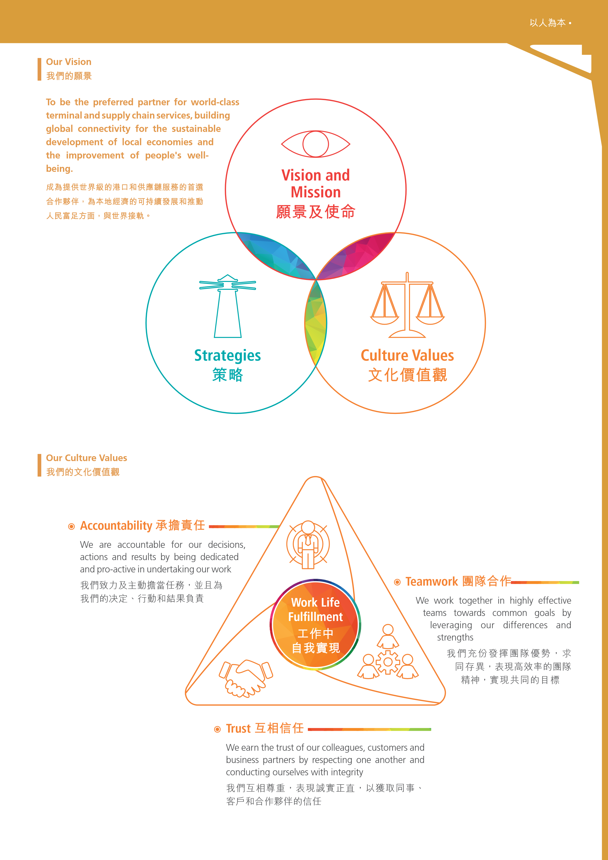
d

In the recent survey, we have seen significant improvement in various areas including safety and well-being, communications, collaboration and teamwork, as well as senior leadership. Whilst we are proud to have achieved significant improvement, we see this as the beginning of our culture journey. From the survey results, we have identified areas for further enhancement. All the survey findings have been openly communicated to our people. Measures and activities are being rolled out at the corporate, business unit and departmental levels.
最新的調查顯示， 我們在安全和健康、溝通、協作和團隊合作，以及管理層領導方面均有明顯的改善。對於取得顯著的進步，我們感到十分鼓舞， 但我們視這為公司文化旅程的起始，我們在調查結果中確立需要進一步改善的地方。所有調查結果已公開地與同事分享，改善措施及活動亦已在公司、業務單位及部門層面推行。

BOOSTING INTERNAL COMMUNICATIONS
Regular engagement with our people regarding important business and operational updates is of utmost importance to our business. We have established various channels to enhance two-way communication, including our bi-monthly newsletter Hoi Ma, Monthly Get Together, monthly Cheer ME (Modern Terminals Employee) Up Station and the bi-monthly Joint Consultation Committee (JCC). We also organize town hall meeting when we need to provide a holistic update on the business environment and connection between all business initiatives. At JCC, elected staff representatives can express the views and concerns of people across the company directly to management representatives.
提升內部溝通
經常與同事分享公司重要業務及運作的最新動向， 對公司的業務發展十分重要。我們設有不同渠道以達致雙向溝通，包括每兩個月出版的員工刊物《海碼》、每月舉行的「暢談一小時」和「現代加油站」，以及每兩個月舉辦一次的勞資協商委員會會議。此外，我們會在有需要時舉辦大會堂會議，提供整體營商環境的資訊及各業務計劃的總覽。而在勞資協商委員會中，由選舉產生的僱員代表可代全體員工直接向管理層代表反映意見。

To boost engagement with our people, especially frontline staff, we launched a new communications platform called ModernChat in Hong Kong in July 2016. The platform, which is easily accessible on smart phones, has been well received by our people. As of December 2017, over 100 chat groups focusing on different topics have been created, with about 1,600 messages shared each month. With ModernChat, our people can receive timely information on business developments, operational updates, our Company’s sustainability efforts, happenings at various departments and more. In January 2017, we launched a similar Corporate Internal WeChat page in DaChan Bay Terminals in western Shenzhen that is open to all employees of our terminals.

The introduction of ModernChat and our WeChat page is our response to feedback received from the culture survey, in which our people indicated the need to enhance internal communication between different levels of staff. In addition, we have received positive feedback on various two-way communication channels stating that the management and frontline staff are better connected with more efficient and transparent communication.
我們於2 0 1 6 年7 月在香港推出全新的溝通平台
「M o d e r n C h a t 」，以提升員工的參與度，尤其希望凝聚前線員工。該平台可以透過智能手機輕易連接， 廣受各員工歡迎。截至2 0 1 7 年1 2 月， 平台已有超過100個不同主題的聊天群組， 每月有約1 , 6 0 0 條訊息。透過「ModernChat」，僱員可及時接收不同資訊，包括業務發展、操作消息、公司在可持續發展方面的工作，以及在不同部門發生的各項事情。在2017年1月，我們位於深圳西部的大鏟灣碼頭透過微信推出類似的公司內部溝通專頁，開放予碼頭的所有僱員。

「ModernChat」及微信專頁的設立， 正是我們對文化調查結果的回應。調查結果顯示，有意見認為公司需要加強不同階層同事間的溝通。除此之外，我們亦收到有關各個雙向溝通渠道的正面回響，表示透過有效及高透明度的溝通， 管理層與各前線員工之間加強了連繫。

NURTURING TALENT
In line with our Employee Value Proposition statement, “Together, We Grow, Excel and Succeed,” we continuously invest in people development.

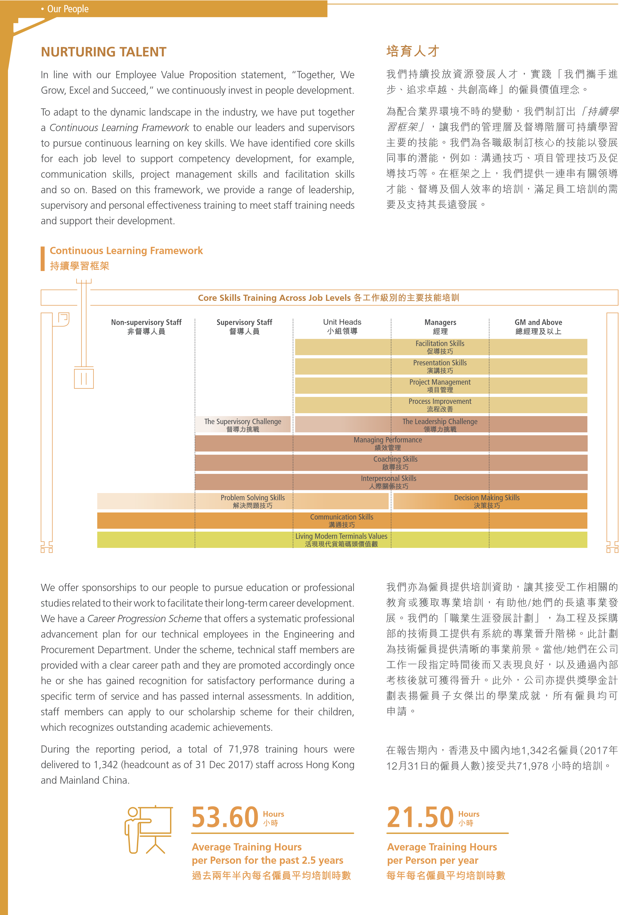
To adapt to the dynamic landscape in the industry, we have put together a Continuous Learning Framework to enable our leaders and supervisors to pursue continuous learning on key skills. We have identified core skills for each job level to support competency development, for example, communication skills, project management skills and facilitation skills and so on. Based on this framework, we provide a range of leadership, supervisory and personal effectiveness training to meet staff training needs and support their development.

培育人才
我們持續投放資源發展人才，實踐「我們攜手進步、追求卓越、共創高峰」的僱員價值理念。

為配合業界環境不時的變動，我們制訂出「持續學習框架」，讓我們的管理層及督導階層可持續學習主要的技能。我們為各職級制訂核心的技能以發展同事的潛能，例如：溝通技巧、項目管理技巧及促導技巧等。在框架之上，我們提供一連串有關領導才能、督導及個人效率的培訓，滿足員工培訓的需要及支持其長遠發展。

We offer sponsorships to our people to pursue education or professional studies related to their work to facilitate their long-term career development. We have a Career Progression Scheme that offers a systematic professional advancement plan for our technical employees in the Engineering and Procurement Department. Under the scheme, technical staff members are provided with a clear career path and they are promoted accordingly once he or she has gained recognition for satisfactory performance during a specific term of service and has passed internal assessments. In addition, staff members can apply to our scholarship scheme for their children, which recognizes outstanding academic achievements.

During the reporting period, a total of 71,978 training hours were delivered to 1,342 (headcount as of 31 Dec 2017) staff across Hong Kong and Mainland China.
我們亦為僱員提供培訓資助，讓其接受工作相關的教育或獲取專業培訓，有助他/她們的長遠事業發展。我們的「職業生涯發展計劃」，為工程及採購部的技術員工提供有系統的專業晉升階梯。此計劃為技術僱員提供清晰的事業前景。當他/她們在公司工作一段指定時間後而又表現良好，以及通過內部考核後就可獲得晉升。此外，公司亦提供獎學金計劃表揚僱員子女傑出的學業成就，所有僱員均可申請。

在報告期內，香港及中國內地1,342名僱員(2017年12月31日的僱員人數)接受共71,978 小時的培訓。

Case Study
參考實例

Talent Development Programme
The Talent Development Programme is designed to strengthen the succession pipeline for the critical positions in our Operations, Engineering and Procurement Departments. Staff showing high potential are identified and developed through a structured system. Various training and development opportunities are provided to participants, including 360-degree assessment, job rotation, cross-team improvement projects, coaching, mentorship scheme as well as exposure opportunities. By the end of 2017, 75% of the people who graduated from this programme have advanced in their careers.

人才發展計劃
「人才發展計劃」旨在加強操作部、工程及採購部重要職位的繼任安排。公司發掘有潛質的僱員參與有系統的發展計劃。計劃為有關僱員提供多元化的培訓及發展機會，包括全方位的評估、工作輪調、跨部門改進計劃、輔導、導師計劃及拓闊眼界的機會。截至2017年年底，75%參與計劃的同事在事業上得到發展。

Case Study
參考實例

Skills Development Sponsorship Scheme
The Skills Development Sponsorship Scheme was launched in October 2016 to encourage our people to acquire relevant knowledge and skills to broaden their career development opportunities, while helping the Company enhance operational efficiency. Under the scheme, people in Operations Department, as well as Equipment Maintenance, and Facilities Maintenance sections of Engineering and Procurement Department are sponsored to learn to drive any one of the following vehicle types: light goods vehicles, private buses, heavy goods vehicles, or articulated vehicles. By the end of the reporting period, a total of 16 staff successfully acquired relevant driving licences since the launch of the scheme.

技能發展資助計劃
「技能發展資助計劃」於2016年10月推出，旨在鼓勵同事學習相關技能以擴闊其事業發展機會， 同時有助公司提升營運效率。在此計劃下，操作部、工程及採購部轄下的機械設備維修組及建設事務維修組的僱員，可獲得資助以學習駕駛以下其中一款車輛，包括輕型貨車、私家巴士、重型貨車，或掛接式車輛。自計劃開展至報告期末， 共有16位同事成功考獲相關駕駛執照。
Case Study
參考實例

Outstanding Employees
In Hong Kong, two of our engineering staff who graduated from the terminal operator’s apprenticeship scheme have received Outstanding Apprentice Awards presented by the Vocational Training Council in 2016 and 2017. This is the first time that apprentices from the Hong Kong container terminal industry have received this award.

An equipment operator and trainer from DaChan Bay Terminals has received an individual and a group award in the 2015 Equipment Operations Competition organized by DaChan Federation of Trade Unions. In addition, the staff member was awarded the 2016 Best Craftsman in Baoan District by Baoan Federation of Trade Unions.

Representatives from DaChan Bay Terminals achieved impressive results at the 9th Shenzhen Worker Innovation and Technology Competition cum 2017 Shenzhen Port Skills Competition. They were named champion and first runner-up in the category of efficient operation of electricity-powered rubber-tyred gantry cranes

傑出員工
在香港，我們有兩位工程人員畢業於公司的學徒訓練計劃，並分別於2016及2017年榮獲由職業訓練局主辦的「傑出學徒獎」。這是首次香港貨櫃碼頭業的學徒獲得該獎項。

大鏟灣碼頭的機械操作員兼導師榮獲由大鏟灣工會基層委員會主辦的2015年公司技能競賽單人及團體雙料冠軍。他更在2016年獲寶安區總工會頒發「寶安工匠」榮譽稱號。

深圳市第九屆職工技術創新運動會暨2017年深圳技能大賽港口領域技能競賽中，大鏟灣碼頭代表隊取得驕人成績，包攬電動裝卸機械司機(即龍門起重機)競賽項目的冠、亞軍。

ENHANCING EMPLOYEE WELLNESS
Employee well-being is a priority for our Company. We promote work-life balance and regularly organize recreational activities for our people and their family members, including the annual dinner, staff outings, movie days, sports competitions, and festival celebration activities.

In Hong Kong, regular body check-ups are offered to eligible full-time staff members, while an Employee Assistance Programme is available and provides 24-hour hotline counseling services for employees and their dependents to relieve stress and seek necessary support.

In June 2016, we launched a programme called Project FIT to promote healthy lifestyles among our people. Over three months, participants can join a number of activities including fitness training, nutrition seminars, fitness assessment and dietary consultation. Employees demonstrating outstanding achievements are awarded certificates and souvenirs. With the overwhelmingly positive feedback from participants, we have already organized three classes benefiting close to 150 staff members.

We have also launched an Interest Group Sponsorship Scheme in June 2017. Under the scheme, we encourage staff with similar interests to have regular gatherings for training and practice in sports, culture and arts. At the end of the reporting period, a total of two interest groups had been formed.

At DaChan Bay Terminals, a Sports Day was held on 12 November 2016 with a theme of Trust, Teamwork and Fun. It featured a number of teambuilding activities and booths for bowling and archery, which were well received by kids of our staff members.
提升僱員身心健康
公司十分重視僱員的身心健康，提倡工作與生活平衡，定期舉辦康樂活動予僱員及其家人，包括周年晚宴、戶外活動、電影日、運動比賽以及節日慶祝活動等。

在香港，我們為全職僱員提供定期身體檢查，同時提供「僱員支援計劃」，讓員工及其家人可透過24 小時全天候熱線紓緩壓力及尋求適切的幫助。

我們於2016年6月推出「我至F I T 計劃」，向僱員宣揚健康的生活方式。參加者在為期三個月的計劃內，參與一連串的活動，包括健身訓練、營養講座、體能測試及個人飲食諮詢，表現傑出的參加者獲頒證書及紀念品。由於參加者反應非常正面積極，公司先後已舉辦三班， 接近150名僱員曾參與。

我們亦於2017年6月推出「興趣小組贊助計劃」，鼓勵擁有共同興趣的僱員，定期參與有關運動、文化及藝術方面的訓練及練習。在報告期末，共有兩個興趣小組已經成立。

大鏟灣碼頭於2016年11月12日舉辦題為「展現信任、攜手合作、共創快樂」的運動會。透過一系列的遊戲讓同事建立團隊合作精神，當中以保齡球及射箭攤位最受僱員的小朋友歡迎。

Case Study
參考實例

Family Day 2017
家庭同樂日
In Hong Kong, we organized a Family Day on 22 October 2017 to celebrate our 45 years of operations. With a theme of Family and Wellness, the event attracted 1,600 employees and their family members, and retirees. The four-hour event featured a variety of activities including game booths, Control Tower and yard tour, body composition analysis and dietician consultation, staff singing performance, rope skipping and freestyle football performance, adrenaline rush competition, and lucky draw. Traditional snacks were also provided for participants.

在香港，為慶祝公司營運45周年，我們於2017年10月22日舉辦「家庭同樂日」。活動以「健康你我他 現代是一家」為主題，吸引1,600名僱員、其家人，以及退休同事參與。同樂日歷時四小時，當中的節目包羅萬有，包括攤位遊戲、碼頭及控制中心導賞團、身體成份分析及營養師會面、員工歌唱表演、花式跳繩及花式足球表演、熱血奔騰障礙賽及幸運大抽獎。當日更有傳統小食供參加者享用。

Separately, our people at DaChan Bay Terminals joined a Family Day on 4 November 2017 at the terminals in western Shenzhen to celebrate its 10th anniversary. The event featured tour of the facilities, performances and game booths with electric cars for kids, remote control cars, virtual reality experience, DIY T-shirts and sun hats, and other activities.

另外，位於深圳西部的大鏟灣碼頭為慶祝成立十周年，於2017年11月4日舉辦「家庭歡樂日」。當日的節目豐富，包括碼頭設施導賞、精彩的表演項目，以及林林總總的攤位遊戲， 包括為小朋友而設的電動車、遙控車、VR場景體驗、手工DIY T恤及太陽帽製作及其他活動。

Case Study
參考實例

Ice-cream Day
開心雪糕日
At container terminals, some of our frontline staff have to work outdoors, sometimes in harsh weather conditions. To show our care and support, we organized an Ice-cream Day for the first time on 15 July 2016 and the second one on 11 August 2017. An ice-cream truck went to different locations at Modern Terminals in Hong Kong bringing the delight to people of different departments, both office and frontline staff. A total of 1,663 of our people and contractors’ workers enjoyed the gesture from our Company each year.

在貨櫃碼頭，部份前線員工需要在戶外工作，有時更要面對惡劣的天氣情況。公司為表示對僱員的關心及支持，先後於2016年7月15日及2017年8月11日舉行「開心雪糕日」。雪糕車停泊在香港現代貨箱碼頭的不同位置，為來自不同部門辦公室及前線同事帶來一點欣喜。每年各有1,663名僱員及承辦商員工享受到公司這窩心的禮物。

HEALTH AND SAFETY
健康及安全

Our Company is committed to providing a healthy and safe working environment for all employees and contractors’ workers. Our ultimate goal is to create an accident free workplace. We have a well-developed occupational health and safety management system in place to integrate health and safety into management and work practices. We engage with our stakeholders, including employees, contractors, and customers, to increase awareness and make continuous enhancements to our health and safety approach.

公司致力為所有僱員及承辦商員工提供健康及安全的工作環境，最終目的是達致零意外。我們備有一套完善的健康及安全管理系統，把健康及安全理念融入日常管理及工作程序中。我們與各持份者包括僱員、承辦商及客戶共同提升健康及安全意識，持續改進健康及安全措施。

The Health and Safety Steering Committee, comprising senior management from various departments, was formed to develop, review and monitor the implementation of our policies while departmental committees drive implementation and promote continual improvement.
我們設有健康和安全指導委員會，由來自不同部門的高級管理人員所組成，負責制定、檢視及監察政策的推行，而部門委員會則負責推動政策的實施及持續改善。

UPGRADING SAFETY MEASURES
Due to the nature of our business, our frontline staff are exposed to certain kinds of potential emergencies. To avoid occurrence and minimize impact in case of an emergency, it is of utmost importance that people working in our facilities understand our health and safety requirements, and that trained emergency teams are in place to handle the situation promptly. We continually enhance our health and safety management system with the measures and programmes discussed in the sections below.

Terminal Health and Safety Promotion Videos
To enhance further the health and safety awareness among our people and our contractors’ workers, a series of six Occupational Safety and Health videos were launched in 2015, which highlighted proper procedures and safety measures in various aspects of our operations.

The videos are available at our website:

提升安全措施
因應公司的業務性質，我們的前線同事需面對種種可能發生的緊急事故。為避免事故發生及將緊急事故的影響減至最低，在碼頭內工作的人員必須清楚了解我們對健康及安全的要求。與此同時，受過訓練的應急團隊在有需要時迅速地處理事故。我們不斷提升健康及安全管理系統，以下是公司採取的措施及計劃。

碼頭健康及安全宣傳短片
為了進一步提升僱員及承辦商員工的健康及安全意識，我們於2015年推出一系列共六條職業安全及健康短片，提醒大家在處理不同工作範疇時所需留意的正確程序及安全措施。

上述短片可在公司網站瀏覽：

www.modernterminals.com/group/index.php/News/about_news_detail/ID/212.html
(Cantonese only)

Work Safe Behaviour Programme
In 2016, we launched the Work Safe Behaviour Programme in Hong Kong, aiming to enhance further the safety performance among our frontline staff in engineering and operations. A total of 16 work processes have been included. Under the programme, a group of safety observers received training from the Occupational Safety and Health Council, and then went to different locations to observe and identify any improper work behaviour, and gave advice and supported the concerned staff to avoid recurrence. We measured the results with our internal safety score which is the number of proper behaviour observed divided by total number of behaviour observed. During the reporting period, we recorded an improvement of 23 percentage point in this score.

工作安全行為計劃
我們於2016年在香港推出「工作安全行為計劃」，旨在進一步提升工程部及操作部前線員工在安全方面的表現。計劃共包括16個工作程序。安全觀察員在接受職業安全健康局的培訓後，會到不同的工作地點觀察有否不恰當的工作行為，並向相關同事提供意見，避免類似情況再次發生。我們會以內部安全分數評估成效，分數的計算方法是以恰當工作行為的數量除以總工作行為的數量。而在報告期內，我們的內部安全分數錄得23個百分點的增長。

23
%
During the reporting period, we recorded an improvement
of 23 percentage point in our internal safety score.
在報告期內，我們的內部安全分數錄得23個百分點的增長

Safe Driving Campaign
Traffic safety within container terminals is of great importance as trucks and mobile equipment such as QCs, E-RTGs, empty stackers, and reach stackers are operating concurrently. We rolled out a Safe Driving Campaign from July to December 2017 to raise staff awareness on safe driving practices, to equip drivers with techniques to prevent accidents and knowledge of hazard perception and safe driving behaviour.

安全駕駛運動
碼頭內的交通安全非常重要，因為貨車以及可移動的設備，例如：岸邊起重機、電力驅動的龍門起重機、貨箱堆高機及伸延式貨櫃吊機，均在同時進行操作。我們在2017年7月至12月期間推出「安全駕駛運動」，以提高各司機/操作員的安全駕駛意識，讓大家掌握防止意外發生的技巧、了解危險預視的知識，以及學習安全駕駛行為。

Defensive and Safe Driving Training

防禦及安全駕駛培訓
We invited a professional tutor from the Hong Kong School of Motoring to deliver a talk on defensive driving on 12 July 2017. Over 50 participants joined the session including staff and contractors’ workers. Separately, we worked with the Hong Kong Police Force to conduct a safe driving talk on 17 October 2017 for more than 60 participants.

我們在2017年7月12日邀請香港駕駛學院的專業導師，就防禦駕駛進行講座，有超過50位僱員及承辦商員工參與。此外，我們在2017年10月17日聯同香港警務處舉辦安全駕駛講座，共有超過 60位參加者。

Traffic Incident Sharing Forum
交通事故分享論壇
Lessons learned from previous incidents enable continuous improvement in safety. On 20 July 2017, we organized a Traffic Incident Sharing Forum in which we had some case studies to highlight the root causes and preventive measures with staff from different departments and contractors.

從以往的事故中吸取經驗可持續提升安全水平。因此，我們在2017年7月20日舉辦「交通事故分享論壇」，與來自不同部門的僱員及承辦商員工分享一些事故發生的原因及預防措施。

Health and Safety Station
職安廣播站
Besides classroom training, we also reached out to our frontline people and contractors’ truck drivers at the yard through our Health and Safety Station. We have conducted four briefing sessions on safe driving covering some 240 drivers from our internal haulage contractors.

除了課堂培訓，我們亦在貨櫃堆場舉辦「職安廣播站」，接觸前線員工及承辦商的貨櫃車司機。我們共舉辦四場安全駕駛簡介會， 共有240名內運承辦商司機參與。

Safe Driving Sticker Design Competition
安全駕駛標貼設計比賽
We launched a Safe Driving Sticker Design Competition in July 2017. The award presentation ceremony was held on 17 October 2017. We produced stickers using the winning design and encouraged drivers to put the stickers on front windscreens or other appropriate locations of the vehicles and mobile equipment to remind them to drive safely.

我們在2017年7月舉辦「安全駕駛標貼設計比賽」，並於2017年 10月17日舉行頒獎禮。我們將得獎作品製作成標貼，鼓勵司機將標貼貼於車頭擋風玻璃、車內或流動設備的其他適當位置，以提醒他們安全駕駛。

BOOSTING HEALTH CONSCIOUSNESS
We spare no effort in promoting a safe working culture and instilling a safety mindset to our staff. At the same time, we continuously improve the workplace environment to foster wellness of people working in our facilities.
提高健康意識
我們致力向僱員推廣安全的工作文化及灌輸安全至上的觀念。與此同時，我們不斷地改善工作環境， 讓各位在碼頭工作的人士工作得更健康。

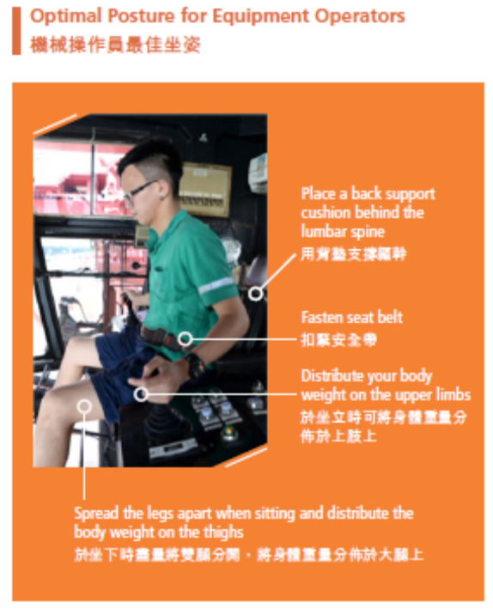
Ergonomic Assessment of Crane Operators
Our equipment operators spend a significant part of their day handling container loading and unloading inside the driving cab of cranes. We appointed ergonomics experts from The Hong Kong Polytechnic University to assess the occupational health risks related to the equipment inside our terminals.

Through the study, the experts identified the optimal posture for equipment operators during the container loading and unloading process in the driving cab, and developed a series of stretching exercises for operators. These stretching exercises have become part of their routine before commencing work shift.

Preventive and Protective Measures
Stretching is important for flexibility, range of motion, relaxation of muscle as well as reduction in risk of injury. We encourage our people to do stretching exercises regularly at home and also in the workplace. On 30 June 2016, we arranged a fitness coach to visit 15 departments to lead staff in stretching exercises to promote this healthy habit. In addition, we have produced a video on the stretching exercises and a QR code was included in the promotional poster for easy access through mobile devices.

On 1 August 2017, we also invited the registered nurse from the Hong Kong Labour Department to conduct a talk on Manual Handling Operations and
Prevention of Back Injuries.

貨櫃裝卸機械操作員人體學評估
我們的機械操作員在日常工作中，大部份時間都需要在起重機的駕駛室內進行貨櫃裝卸的工作。因此，我們委託香港理工大學的人體力學專家為碼頭內的機械進行職業健康風險評估。

透過評估，專家為需要在駕駛室裝卸貨櫃的操作員制定最理想的姿勢，並為操作員設計一系列伸展運動。這些伸展運動更成為他們工作前的指定活動。

預防及保護措施
伸展運動對身體靈活性、柔軟度、肌肉放鬆及減少受傷機會十分重要，我們鼓勵同事經常在家中及工作地方進行伸展運動。我們於2016年6月30日安排健身教練到15個部門帶領同事進行伸展操， 從而推廣這個健康的習慣。此外，我們亦製作有關伸展運動的短片，大家只需透過宣傳海報上的二維碼，便可輕易地透過行動裝置收看。

在2017年8月1日，我們更邀請勞工處的註冊護士就「體力處理操作及預防背部勞損」進行講座。

Emergency Drill
Together with the Hong Kong Police Force and Hong Kong Fire Services Department, we organized an emergency drill on 8 May 2017. This year, we practised our response to situations involving chemical leakages and discovery of weapons.

The Emergency Handling on Leakage of Dangerous Goods and Port Facilities Security Drill for Shenzhen Port hosted by Shenzhen Ports and Cargo Transportation Administration Bureau was successfully completed on 27 October 2017 at DaChan Bay Terminals. During the drill, the handling procedures were tested in a simulation scenario of a large containership leaking class 3 flammable liquid when at berth. A command and control centre was set up and rescue procedure was initiated.

緊急事故演習
我們在2017年5月8日聯同香港警務處及香港消防處舉辦緊急事故演習，演習內容涉及化學品洩漏及發現炸彈。

由深圳市港航和貨運交通管理局主辦的深圳港危險貨物洩漏應急處置暨港口設施保安演習已於 2017年10月27日在大鏟灣碼頭成功完成。演習模擬一艘大型貨櫃船在靠泊碼頭作業期間，洩漏第三類易燃液體。當局隨即成立應急救援指揮及控制中心及開展救援程序。

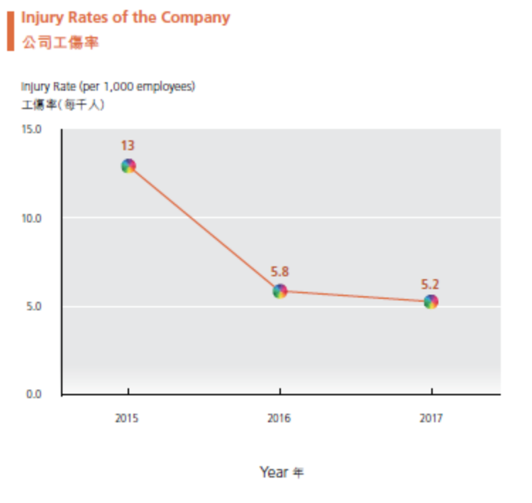
Although safety and risk management measures are in place, it is with extreme regret that we had one fatality in June 2016. A subcontractor’s worker at Modern Terminals was suspected to have received electric shock during the heightening works of a quay crane. The Labour Department, having investigated the case, laid no charges against Modern Terminals for this accident.

儘管公司已經有一套安全及風險管理措施，很遺憾地在2016年6月仍發生了致命意外。一名分包商員工於碼頭進行岸邊起重機加高工程時懷疑觸電。勞工處經調查後並沒有就是次意外對現代貨箱碼頭提出起訴。

We are committed to creating and operating environmentally friendly container terminals. Environmental protection is among our top priorities and is an integral part of our decision-making processes. Guided by our Corporate Environmental Policy, all business units align their individual environmental policies with the corporate policy.
ENVIRONMENT
環境

我們致力創建及營運一個環保的貨箱碼頭。保護環境是我們的首要任務之一，亦是我們決策過程中不可或缺的要素。在企業環保政策的指引下，所有業務單位的環保政策均符合企業環保政策的原則。

CONTINUOUS IMPROVEMENT
Both Modern Terminals in Hong Kong and DaChan Bay Terminals in western Shenzhen have received ISO14001 certification for their environmental management systems since 2009 and 2013 respectively. Modern Terminals in Hong Kong achieved ISO14001:2015 certification in November 2015, two months after the new standard was released, becoming one of the first organizations in Greater China to achieve the updated standard. DaChan Bay Terminals obtained the same accreditation in September 2017. The 2015 version has a wider scope that includes stakeholder engagement, environmental leadership and commitment, greater protection for the environment with a focus on proactive initiatives, life-cycle thinking and risk and opportunity identification, and communications both internally and externally.
持續改善
香港現代貨箱碼頭及位於深圳西部的大鏟灣碼頭分別自2009年及2013年起，獲得ISO 14001環境管理系統認證。香港現代貨箱碼頭更在新版本推出的兩個月後，即2015年11月獲得ISO14001:2015認證， 成為首批在大中華獲得新版本認證的企業。大鏟灣碼頭亦在2017年9月獲得該認證。2015新版本涵蓋的範疇更廣，包括持份者溝通、環保領導力及承諾、著重主動建立更能保護環境的措施、對整個生命周期的考慮、風險及機會的識別，以及對內及對外的溝通。

STEPPING UP ENERGY SAVING AND EMISSION REDUCTION EFFORTS
We always strive to reduce our energy consumption and emissions by deploying equipment with the latest technology or powered by green energy. With the completion of conversion of all our diesel-powered Rubber-tyred Gantry Cranes (RTGs) to Electricity-powered RTGs (E-RTGs) in 2014 in Hong Kong, we have made significant achievements to reduce emissions. In the last ten years, we have reduced our carbon emissions per twenty-foot equivalent unit (TEU) from 14.39 kg to 10.12 kg, translating into a reduction of 27,500 metric tonnes in 2017 comparing with 2008 emission performance. Our efforts to reduce energy consumption and carbon emissions continue.

LED Light Replacement
In our offices, we replaced 4,000 lights with LEDs across our Hong Kong facilities in 2016. When compared to conventional fluorescent tubes, LED lights consume 50% less power and last three times longer. The LED lights we use are certified with Restriction of Hazardous Substances (RoHS) which are lead free and mercury free. We take the opportunity when renovating our facilities to switch to LED lights, for example during the renovation of our staff cafeteria in 2017.

In the yard area, the LED lights replacement on E-RTGs was completed in Hong Kong after a one-year pilot to ensure the lights were suitable for extreme conditions. As a result, all HID lamps on 83 units of E-RTGs were replaced with LED lights. LED lighting on E-RTGs uses 70% less electricity than traditional HID lamps.

We have achieved an estimated saving of 3 million kWh annually during the reporting period.

進一步節能及減排

為節省能源及減少氣體排放，我們採用備有先進技術或以綠色能源驅動的設備。我們於2014年在香港完成將所有柴油驅動的膠輪式龍門起重機改為以電力驅動，成功將排放量大大減少。過去十年， 我們將每標準箱的二氧化碳當量排放由14.39公斤減至10.12公斤，即與2008年的排放表現相比，我們在2017年減少氣體排放約27,500公噸。公司將繼續減少使用能源及減低碳排放。

改用LED燈照明
在香港，我們於2016年為辦公室換上4000盞LED 燈。與傳統的熒光燈光管相比，LED燈所消耗的電力少50%，壽命卻長三倍。公司所採用的LED燈均符合「限制電器及電子設備使用有害物質」指令， 不含鉛及水銀。我們會在設施需要翻新時換上LED 燈，例如於2017年翻新公司的員工餐廳時。

而在堆場內，我們完成為期一年的測試，確保LED 燈在極端環境下依然適合使用，並已經完成為電力驅動的膠輪式龍門起重機更換LED燈的工作。共有83台電力驅動的膠輪式龍門起重機上的所有HID燈已換成LED燈。在電力驅動的膠輪式龍門起重機上使用LED燈所耗用的電力較傳統HID燈低70%。

在報告期內，我們估計每年節省用電約300萬千瓦時。

Installation of oil-free chillers
Modern Terminals in Hong Kong has replaced six units of conventional aircooled chillers with screw compressors by oil-free magnetic bearing chillers in 2017, saving 29% of electricity.

Shore power system at DCB
After a year and a half of planning, the installation of shore power for two berths at DCB was completed in late 2016 and the system has been in operation since January 2017 with “OOCL Taipei” being the first vessel using it on 22 January 2017. With the shore power system, carbon emissions can be reduced as vessels can switch off their auxiliary engine while berthing.

安裝無油磁浮式製冷機
香港現代貨箱碼頭已於2017年將六台傳統製冷機更換為無油磁浮式製冷機，減少電力消耗達29%。

大鏟灣碼頭的岸電系統
經過為期一年半的規劃，大鏟灣碼頭於2016年年尾完成在兩個泊位安裝岸電設施，並於2017年1月開始啟用，「東方台北」號率先於2017年1月22日使用該設施。岸電系統使船隻在靠泊時能關掉輔助引擎，有助減低碳排放量。

WASTE MANAGEMENT
We are committed to minimizing waste by adopting the 4R principles – reduce, reuse, recycle and replace – and recycling facilities are available throughout our premises. To gather more information on our waste profile to develop appropriate measures, we carried out a municipal solid waste statistic and monitoring programme from April to July 2014 in Hong Kong. We plan to conduct another round of study in 2018. Under the programme, we deploy staff to designated locations to gather the refuse bags and sort waste including those to be separated for recycling. All waste materials are weighted and recorded. As a result of the last study, we have added more collection points for recycling to provide convenient access and included glass in our recycling efforts. In 2015, we started a food waste recycling initiative to reduce the amount of food waste we generate.
固體廢物處理
我們致力減少廢物，切實執行4R環保原則，包括減少使用、物盡其用、循環再造及替代使用，在碼頭的不同地方均設有回收設施。為收集更多有關固體廢物的資料並制定相應措施，公司於2014年4月至7月期間在香港進行固體廢物統計及監察計劃，並計劃於2018年進行另一輪統計。在此計劃下，我們安排同事到指定地點收集垃圾袋，包括一般垃圾和可回收的垃圾，並將垃圾分類，然後磅重及記錄。在上次計劃後，我們增設更多更方便同事的回收點，同時將玻璃納入我們的回收項目。在2015年， 我們進行廚餘回收計劃，減少廚餘的數量。

With our facilities located at the waterfront, it is of utmost importance that we minimize our impacts on water quality by placing emphasis on sewage treatment and spillage prevention. Sewage from our terminals is either treated through the fuel interceptors on-site or transported to sewage treatment facilities before discharging into the sea. Our staff members are trained on how to deal with any possible chemicals spillage and leakage according to our Emergency Response for Chemical Spillage.
我們的設施臨海而建，故此我們十分重視污水處理及防止洩漏工作，盡可能減低對水質的影響。碼頭的污水在排出大海前，會經過現場的燃油分隔系統或運至污水處理設施處理。公司有關僱員亦受過相關培訓，根據「化學品洩漏緊急應變程序」處理可能發生化學品洩漏的情況。

SUPPORTING BIODIVERSITY AND ECOSYSTEMS
Biodiversity is crucial to the stability of ecosystem services to which human well-being is intimately linked. We conduct environmental impact assessment for our major projects as part of the ISO14001 environmental management system and have carried out measures to minimize it.

To help protect ecosystems that our business operations interact with, we have developed the Handling Procedure of Discovering Wild Animals or Endangered Species in December 2015. The guideline lists out the steps one should take if encounter any suspected 1) wild animals or endangered species, and 2) old and valuable tree species. To raise the awareness of biodiversity conservation among our people, we arranged three rounds of exhibitions at our Hong Kong facilities in August 2016. The exhibition introduced different endangered species found in Hong Kong, with relevant legislations, and common wild animals discovered at the container terminals.

In November 2016, a total of 95 participants, including Modern Terminals employees and their families, joined an eco-tour to Hoi Ha Wan and Kat O Nature Trail to learn more about the coral communities and marine life as well as different landforms and rocks.
支持生物多樣性及生態保育
生物多樣性對維持生態系統的穩定性非常重要，這亦與人類的福祉有密切關係。作為ISO 14001環境管理系統的一部份，我們對主要項目進行環境影響評估，並採取措施將影響盡量減至最低。

為保護碼頭周邊的環境及生態系統，我們於2015年 12月制定一份「發現野生動物或瀕危動植物處理程序」。該指引列出遇到任何可能是(1)野生動物或瀕危物種，以及(2)古樹及珍貴樹木品種時，所應採取的步驟。為提升僱員對生物多樣性的保育意識，我們在2016年8月於香港進行三場展覽，介紹在香港發現的不同瀕危物種、相關法例，以及在貨櫃碼頭較常見的野生動物。

2016年11月，共有95位現代貨箱碼頭僱員及其家人參與「海下灣賞珊瑚暨吉澳生態遊」，了解更多有關珊瑚群、海洋生物、不同地貌及岩石的知識。

Case Study
參考實例

New QC Project
We integrate environmental considerations in all stages of equipment lifecycle. In Hong Kong, we have taken delivery of five new quay cranes to replace old ones in October 2017. The internal surfaces of the crane structure are coated with a water-based paint with a very low content of volatile organic compound (VOC). More than 95% of VOC content is reduced when compared to conventional solvent-based paint. The old cranes were transported to a recycling company where useful parts and materials were recycled.

新岸邊起重機項目
在設備的不同生命周期，公司均會考慮到與環境有關的因素。在香港，我們於2017年10月接收五部全新的岸邊起重機以取代舊有的設備。新岸邊起重機結構的內部表面塗上只含少量揮發性有機化合物的水性重防腐塗料，與傳統塗料相比其揮發性有機化合物含量減少超過95%。舊的岸邊起重機則被送往一家回收公司，將有用的部份及材料回收。

Green Open Day in Shenzhen
DaChan Bay Terminals co-organized the Green Open Day, sponsored by Shenzhen Port Association, on 1 June 2017. More than 60 people joined the activity including citizens, members from National People’s Congress and media. The event’s purpose was to promote the environmental achievements and initiatives of the terminals to target stakeholders.

深圳綠色環保開放日
由深圳港口協會贊助、大鏟灣碼頭合辦的綠色環保開放日於2017年6月1日舉行，超過60位市民、全國人民代表大會成員，以及傳媒朋友參與是次活動。活動旨在向目標持份者推廣碼頭在環保方面的成就及措施。

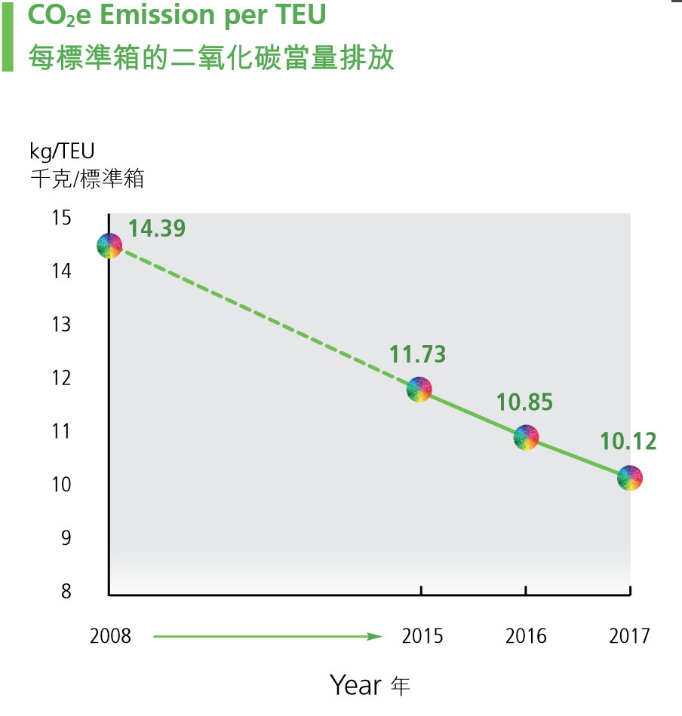
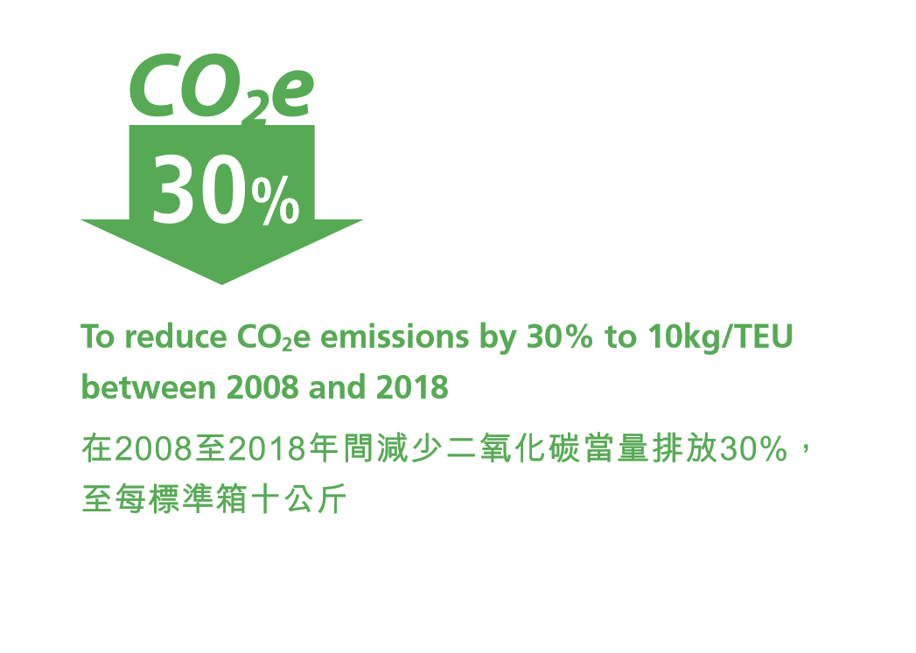

COMMUNITY INVOLVEMENT
社區參與
We believe engaging with the communities in which we operate is critical to the sustainability performance of our business, and we actively support non-governmental organizations (NGOs) on their community initiatives. In 2016, we conducted a strategic review of our community involvement approach and decided to focus on supporting three areas: youth development, promoting environmental awareness, and promoting sports to lead a healthy life. Looking forward, we will apply the areas into our existing community efforts and volunteer activities.

我們相信要維持業務的可持續發展必須融入業務單位所在的社區，因此我們積極支持非政府機構開展的社區活動。我們在2016年就社區參與政策進行策略性檢視，決定專注在以下三方面的工作，包括青年發展、推廣環保意識，及提倡多做運動帶來健康生活。在未來，以上的範疇將適用於我們的社區參與及義工活動。

ENRICHING OUR OWN INITIATIVES
Our community initiatives are tailored to the specific needs of our communities. We continue to support the Cotton Spinners Association Secondary School (CSA) by providing funding and working with the school to provide training to the students and broaden their world view. To enhance our support for healthy lifestyles, we initiated our own community programme in 2017 called Modern Terminals Summer Fitness Programme.
充實公司主辦的社區活動
我們的社區活動針對區內的不同需要而設。公司繼續支持棉紡會中學，透過提供資金以及與學校合作，為同學帶來培訓及擴展視野的機會。為加強推廣健康的生活方式，我們於2017年推出名為「現代貨箱碼頭夏日運動站」 的社區活動。

Modern Terminals Summer Fitness Programme
We partnered with YMCA New Territories Centre to launch the Modern Terminals Summer Fitness Programme on 22 July 2017. The programme is open to children aged between 8 and 12 from low-income families in Kwai Tsing and CSA, as well as children of our employees. It aims to promote sports and to encourage people to live an active and healthy life.

As part of the programme, participants took part in five sessions of sports training and personal development activity. Besides learning a new sport, having fun and building self-confidence, parents of participating children were also invited to join a half-day adventure where parents could spend valuable time with their children.

The programme was conducted in two batches, starting in July and September 2017 respectively. A total of 37 participants received training on rope skipping or “dodgebee”, a game that combines elements of dodgeball and frisbee. Members of Modern Volunteer Force (MVF), our corporate volunteering team, were onsite to help conduct the training. A closing ceremony was held on 12 November 2017 at Modern Terminals to wrap up the programme. More than 70 people, including programme participants and their parents, joined the ceremony.

Overall, 94% of programme participants reported that they have mastered the basic skills of the sport they learnt, and 87% of them reported that they have developed a habit of taking part in sports. Over 80% indicated that they enjoyed the programme.
現代貨箱碼頭夏日運動站
公司與香港中華基督教青年會新界會所合作，於2017年7月22日推出「現代貨箱碼頭夏日運動站」， 歡迎8至12歲，來自葵青區低收入家庭的兒童、棉紡會中學的學生，以及公司同事的小朋友參與。主要目的是推廣運動，並鼓勵大家過積極健康的生活。

在計劃中，參加者參與一共五節的運動訓練及個人成長活動。除了讓參加者學習新的運動項目、享受當中的樂趣及提升自信外，家長亦獲邀出席親子歷奇半日營，讓家長可與小朋友共度寶貴的時光。

活動共分兩期，分別在2017年的7月及9月舉行。共有3 7 名參加者接受花式跳繩或躲避盤訓練， 躲避盤是一個結合躲避球及飛盤元素的遊戲。活動期間，「現代仁」義工隊的成員亦在場協助提供訓練。我們於2017年11月12日在現代貨箱碼頭舉行嘉許禮，意味著活動完滿結束，當日有超過70位活動參加者及其家人出席。

總括而言，有94%的參加者表示他們能掌握所學運動的基本技巧，87%的參加者表示培養了做運動的習慣。超過80%參加者表示他們享受是次活動。

Project WeCan
Since 2011, we have been providing support to our partner school CSA under Project WeCan that aims to improve the overall performance of Hong Kong secondary school students. While it was originally a six-year programme, we have extended our support to 2021. Since the launch of the programme, the Company has provided a total of HK$15 million to equip our partnering school with the necessary hardware and initiatives to enhance its overall performance. Various activities were organized to assist students with their learning progress, facilitate their personal development, and inspire their career planning.
學校起動計劃
自2011年起，我們持續為「學校起動」計劃的夥伴學校棉紡會中學提供支援，該計劃旨在協助香港中學生提升整體表現。此計劃原本為期六年，我們將計劃延長至2021年。公司自計劃開展以來，共提供1,500萬港元予我們的夥伴學校，用以配置所需的硬件及舉辦有助提升整體表現的活動。活動種類十分多元化，以協助學生提升學習進度、促進個人成長，以及啟發他們就其事業作出規劃。

Partner School Performance
In the past seven years, we have seen CSA improve in many ways, including academic performance. In the school year 2016/17, 85% of graduates were pursuing further study with 21% taking bachelor degree courses at universities in Hong Kong or abroad.

CSA received external recognition of its performance, including the Chief Executive’s Award for Teaching Excellence 2012-13 (Guidance and Discipline); the Caring School Award for nine consecutive years since 2008/09; and the Award for Outstanding School for Newly Arrived Students in the Caring School Award Scheme in 2012-13.

In 2015, the CSA Home Day Camp was awarded the Grand Prize in the SchoolLike Awards (Activity) organized by The Hong Kong Federation of Youth Groups and the Education Bureau. Our Company provided funding and support for the design of the CSA Home in 2013. The home-like setting in the facility offers students a unique and valuable experience to help enhance their independence and inter-personal skills.

夥伴學校的表現
在過去七年，棉紡會中學在各方面的進步有目共睹，當中包括學業成績。在2016/17學年， 學校有85%畢業生繼續升學，當中有21%畢業生在香港或海外升讀學士學位課程。

棉紡會中學的表現亦獲得外界的肯定，包括獲頒2012-13年行政長官卓越教學獎（訓育及輔導）、自2008/09年起連續九年獲「關愛校園」獎， 並於2012-13年度獲關愛校園獎勵計劃的「最關顧新來港學生適應」獎。

在2015年，「棉紡人家體驗日營」榮獲由香港青年協會及教育局舉辦「讚好校園」計劃的「讚好活動」大獎。公司於2013年為「棉紡人家」的設計提供資金及支援。該設施以「家」為設計概念，為同學提供一個獨特而寶貴的學習經驗， 有助同學提升自我管理及與人溝通合作的能力。

E-Chat@ModernTerminals
Since 2015, we have been offering a programme called E-Chat@ ModernTerminals to encourage CSA students to practice their English oral skills. In the 2017/18 school year, we engaged a total of 30 Form 3 to Form 5 students in the programme and six senior executives participating as mentors. There are six sessions in a school year and each session lasts about an hour. In the 2016/17 school year, participating students completed a questionnaire and it is encouraging to have received a satisfaction score of 8.2 out of 10.

E-Chat@ModernTerminals
公司自2015年舉辦E-Chat@ModernTerminals 活動，鼓勵棉紡會中學的同學練習英文口語的技巧。在2017/18學年，活動共有30位就讀中三至中五的學生參加，並邀得六位高級行政人員擔任導師。活動於每學年舉辦六次，每次約一小時。在2016/17年，參加活動的同學完成一份問卷，結果顯示同學對活動的滿意度達到8.2分（10分為滿分），令人鼓舞。

ENHANCING VOLUNTEERING EFFORTS
Our corporate volunteering team, Modern Volunteer Force (MVF), has been serving the community since 2007 and now has a total of 241 members. In 2017, the MVF Committee reviewed and aligned its activity plan with the new community involvement areas. Below are some of the activity highlights.

致力推動義工活動
公司的「現代仁」義工隊自2007年開始服務社會， 現有成員共241名。在2017年，「現代仁」委員會重新檢視活動計劃，以配合新的社區參與工作的焦點。以下是「現代仁」部份主要活動。

Midnight Outreach - Young Night Drifters Service
On 19 May 2017, five of our MVF members joined the Youth Outreach social worker team on a midnight outreach activity trying to help young night drifters in Tin Shui Wai, a district of Hong Kong. In the late hours, they proactively approached youth on the streets and informed them of Youth Outreach’s services. This initiative can help keep young people from bad influences.

深宵外展 – 夜遊青少年服務
「現代仁」義工隊的五位成員於2017年5月19日參與深宵外展活動，聯同協青社的社工隊前往天水圍 （香港其中一個地區），關顧夜遊青少年的需要。同事於凌晨時分主動與街上的青少年接觸，並向他們介紹協青社的服務。活動有助防止青少年受到不良影響。

WWF Mai Po Activity and Tree Planting and Forest Conservation Workshop
Our MVF members participated in a number of events to help support the environmental protection. As a Corporate Member of WWF, we worked with them to organize an event on 7 October 2017 for 20 MVF members to help remove invasive species at Mai Po Nature Reserve. On 25 November 2017, a group of 15 volunteers joined a tree-planting and forest conservation workshop on Peng Chau. The workshop was organized by Hong Kong Green Nature Union and The Committee of International Million Tree (Forest) Project and Network – Hong Kong Region under the United Nations Environment Programme. During the event, our volunteers acquired an understanding of reforestation in Hong Kong and the value of native trees, and planted many saplings on the hill slopes.

世界自然基金會米埔活動、植樹及護理工作坊

我們的「現代仁」義工隊成員透過參與一連串的活動，身體力行支持環保。公司作為世界自然基金會的會員，於2017年10月7日與基金會合作舉辦活動，當日有20名「現代仁」義工到米埔自然護理區清除雜草。另外，公司的15名義工於2017年11月25 日前往坪洲參加植林及護理工作坊。該活動由香港綠色自然聯盟及聯合國環境署-國際百萬森林計劃香港區委員會舉辦。義工在活動期間了解到香港的植林情況、本地樹木的價值，並在山坡上栽種了不少小樹苗。

Ngong Ping Charity Walk
We have supported the Ngong Ping Charity Walk in Hong Kong for many years, and in 2016 and 2017, a total of 72 and 64 participants respectively, including colleagues and their family members, students from our partner school CSA, and our customers, joined the event. In both years, we won the “Best Participatory Award – Private Sector”. In 2017, we won three more awards including the 3rd place in the Challenge 20km (Corporate Team), and the 2nd and 4th place in the Challenge 20km (4-Member Team). The Ngong Ping Charity Walk is the annual fundraising event of the Hong Kong Youth Hostels Association and the fund is used to promote environmental protection and support youth development.
昂步棧道慈善步行
公司多年來一直支持在香港舉行的「昂步棧道」慈善步行活動，在2016及2017年，分別有72及64人參與，參加者包括同事及其家人、公司夥伴學校棉紡會中學的同學，以及我們的客戶。我們在2016及2017年均榮獲「最踴躍參與獎 – 私營機構組別」。而在2017年，我們更贏得另外三個獎項， 包括挑戰20公里（機構組）第三名，以及挑戰20公里（四人組）的第二及第四名。「昂步棧道」慈善步行活動是香港青年旅舍協會一年一度的籌款活動，所籌得的款項會用於推廣環保，以及支持青年發展。

Hong Kong Reef Check
For over a decade, the Modern Terminals diving team has supported the annual survey of corals in Hong Kong to promote ecological awareness. Our Reef Check team of divers surveyed the abundances, diversity and health of corals at a designated survey site within Hong Kong waters. Hong Kong Reef Check is organized by the Agriculture, Fisheries and Conservation Department of Hong Kong.

香港珊瑚礁普查活動
十多年來，現代貨箱碼頭潛水隊一直支持一年一度的香港珊瑚礁普查活動，藉此宣揚生態保育意識。公司珊瑚礁普查隊的潛水員在香港水域內的指定區域檢查珊瑚的覆蓋率、多樣性及健康情況。香港的珊瑚礁普查活動由香港漁農自然護理署舉辦。

PERFORMANCE STATISTICS 統計數據摘要
EMPLOYMENT 僱員
 |  |  | Unit  單位 |  | Jul-Dec 2015  2015年7月-12月 |  |  |  |  | Total  總數 | Jan-Dec 2016  2016年1月-12月 |  |  |  |  | Total  總數 | Jan-Dec 2017  2017年1月-12月 |  |  |  |  | Total  總數
 |  |  |  |  | Hong Kong  香港 |  | Mainland China  中國內地 |  |  | Total  總數 | Hong Kong  香港 |  | Mainland China  中國內地 |  |  | Total  總數 | Hong Kong  香港 |  | Mainland China  中國內地 |  |  | Total  總數
Profile of Workforce  僱員總人數 | Total number of staff  僱員總人數 |  | Number數目 |  | 962 |  | 426 |  |  | 1,388 | 958 |  | 421 |  |  | 1,379 | 929 |  | 413 |  |  | 1,342
By Gender  按性別劃分 | Directly employed staff (Male)  直接聘請的僱員(男性) |  | Number數目 |  | 851 |  | 356 |  |  | 1,207 | 848 |  | 352 |  |  | 1,200 | 823 |  | 343 |  |  | 1,166
By Gender  按性別劃分 | Directly employed staff (Female)  直接聘請的僱員(女性) |  | Number數目 |  | 111 |  | 70 |  |  | 181 | 110 |  | 69 |  |  | 179 | 106 |  | 70 |  |  | 176
By Employment Category  按職位類別劃分 | Management staff (Male)  管理層職員(男性) |  | Number數目 |  | 43 |  | 13 |  |  | 56 | 46 |  | 16 |  |  | 62 | 40 |  | 16 |  |  | 56
By Employment Category  按職位類別劃分 | Management staff (Female)  管理層職員(女性) |  | Number數目 |  | 19 |  | 7 |  |  | 26 | 21 |  | 7 |  |  | 28 | 20 |  | 6 |  |  | 26
By Employment Category  按職位類別劃分 | Senior staff (Male)  高級職員(男性) |  | Number數目 |  | 145 |  | 63 |  |  | 208 | 155 |  | 73 |  |  | 228 | 153 |  | 74 |  |  | 227
By Employment Category  按職位類別劃分 | Senior staff (Female)  高級職員(女性) |  | Number數目 |  | 50 |  | 18 |  |  | 68 | 46 |  | 24 |  |  | 70 | 44 |  | 32 |  |  | 76
By Employment Category  按職位類別劃分 | General staff (Male)  普通職員(男性) |  | Number數目 |  | 663 |  | 280 |  |  | 943 | 647 |  | 263 |  |  | 910 | 630 |  | 253 |  |  | 883
By Employment Category  按職位類別劃分 | General staff (Female)  普通職員(女性) |  | Number數目 |  | 42 |  | 45 |  |  | 87 | 43 |  | 38 |  |  | 81 | 42 |  | 32 |  |  | 74
By Employment Category  按職位類別劃分 | Mainland China-based staff (Male)  駐中國內地職員(男性) |  | Number數目 |  | 9 |  | 356 |  |  | 365 | 10 |  | 352 |  |  | 362 | 6 |  | 343 |  |  | 349
By Employment Category  按職位類別劃分 | Mainland China-based staff (Female)  駐中國內地職員(女性) |  | Number數目 |  | 0 |  | 70 |  |  | 70 | 0 |  | 69 |  |  | 69 | 0 |  | 70 |  |  | 70
By Employment Category  按職位類別劃分 | Hong Kong-based staff (Male)  駐香港職員(男性) |  | Number數目 |  | 842 |  | 0 |  |  | 842 | 838 |  | 0 |  |  | 838 | 817 |  | 0 |  |  | 817
By Employment Category  按職位類別劃分 | Hong Kong-based staff (Female)  駐香港職員(女性) |  | Number數目 |  | 111 |  | 0 |  |  | 111 | 110 |  | 0 |  |  | 110 | 106 |  | 0 |  |  | 106
By age group  按年齡組別劃分 | Below 30 (30歲以下) |  | Number數目 |  | 101 |  | 185 |  |  | 286 | 107 |  | 155 |  |  | 262 | 93 |  | 119 |  |  | 212
By age group  按年齡組別劃分 | 30 - 39 (30至39歲) |  | Number數目 |  | 216 |  | 186 |  |  | 402 | 216 |  | 199 |  |  | 415 | 216 |  | 223 |  |  | 439
By age group  按年齡組別劃分 | 40 - 49 (40至49歲) |  | Number數目 |  | 289 |  | 50 |  |  | 339 | 268 |  | 60 |  |  | 328 | 262 |  | 63 |  |  | 325
By age group  按年齡組別劃分 | 50 or above (50或50歲以上) |  | Number數目 |  | 356 |  | 5 |  |  | 361 | 367 |  | 7 |  |  | 374 | 358 |  | 8 |  |  | 366
 | % of employees covered by collective bargaining agreement  集體協商協議保障的僱員百分比 |  | Percentage  百分比 |  | N/A |  | 100 |  |  |  | N/A |  | 100 |  |  |  | N/A |  | 100
New hires 新入職人數 | Male 男性 |  | Number數目 |  | 5 |  | 6 |  |  | 11 | 63 |  | 16 |  |  | 79 | 55 |  | 12 |  |  | 67
New hires 新入職人數 | Female 女性 |  | Number數目 |  | 4 |  | 0 |  |  | 4 | 20 |  | 7 |  |  | 27 | 14 |  | 9 |  |  | 23
New hires 新入職人數 | Below 30 (30歲以下) |  | Number數目 |  | 7 |  | 4 |  |  | 11 | 38 |  | 16 |  |  | 54 | 31 |  | 12 |  |  | 43
New hires 新入職人數 | 30 - 39 (30至39歲) |  | Number數目 |  | 1 |  | 2 |  |  | 3 | 27 |  | 3 |  |  | 30 | 23 |  | 8 |  |  | 31
New hires 新入職人數 | 40 - 49 (40至49歲) |  | Number數目 |  | 1 |  | 0 |  |  | 1 | 14 |  | 4 |  |  | 18 | 13 |  | 1 |  |  | 14
New hires 新入職人數 | 50 or above (50或50歲以上) |  | Number數目 |  | 0 |  | 0 |  |  | 0 | 4 |  | 0 |  |  | 4 | 2 |  | 0 |  |  | 2
Turnover 離職人數 | Male 男性 |  | Number數目 |  | 17 |  | 6 |  |  | 23 | 28 |  | 16 |  |  | 44 | 35 |  | 16 |  |  | 51
Turnover 離職人數 | Female 女性 |  | Number數目 |  | 2 |  | 2 |  |  | 4 | 16 |  | 6 |  |  | 22 | 14 |  | 7 |  |  | 21
Turnover 離職人數 | Below 30 (30歲以下) |  | Number數目 |  | 8 |  | 4 |  |  | 12 | 11 |  | 12 |  |  | 23 | 19 |  | 8 |  |  | 27
Turnover 離職人數 | 30 - 39 (30至39歲) |  | Number數目 |  | 6 |  | 4 |  |  | 10 | 19 |  | 8 |  |  | 27 | 20 |  | 12 |  |  | 32
Turnover 離職人數 | 40 - 49 (40至49歲) |  | Number數目 |  | 2 |  | 0 |  |  | 2 | 6 |  | 2 |  |  | 8 | 6 |  | 3 |  |  | 9
Turnover 離職人數 | 50 or above (50或50歲以上) |  | Number數目 |  | 3 |  | 0 |  |  | 3 | 8 |  | 0 |  |  | 8 | 4 |  | 0 |  |  | 4
Return to work and retention rates after Maternity / Paternity leave, by Gender  按性別劃分的育兒假後復工和保留人數 | Paternity leave 侍產假 |  | Number數目 |  | 4 |  | 7 |  |  | 11 | 14 |  | 36 |  |  | 50 | 10 |  | 30 |  |  | 40
 | Materniity leave 產假 |  | Number數目 |  | 2 |  | 4 |  |  | 6 | 4 |  | 3 |  |  | 7 | 4 |  | 5 |  |  | 9
 | Return to work rate 復工比率 |  | Percentage  百分比 |  | 100 |  | 100 |  |  | 100 | 100 |  | 100 |  |  | 100 | 100 |  | 100 |  |  | 100
Average hour of training by gender  按僱員性別劃分的平均培訓時數 | Male 男性 |  | Hour 小時 |  | 13.33 |  | 4.03 |  |  | 10.58 | 28.14 |  | 10.21 |  |  | 22.88 | 19.77 |  | 19.91 |  |  | 19.81
Average hour of training by gender  按僱員性別劃分的平均培訓時數 | Female 女性 |  | Hour 小時 |  | 9.94 |  | 3.90 |  |  | 7.61 | 23.74 |  | 9.92 |  |  | 18.41 | 24.96 |  | 19.00 |  |  | 22.59
Average hour of training by employment category  按職位劃分的平均培訓時數 | Management Staff 管理人員 |  | Hour 小時 |  | 9.74 |  | 4.27 |  |  | 8.40 | 33.62 |  | 9.30 |  |  | 27.40 | 18.37 |  | 18.76 |  |  | 18.47
 | Senior staff 高級職員 |  | Hour 小時 |  | 18.76 |  | 4.43 |  |  | 14.55 | 40.23 |  | 9.26 |  |  | 30.15 | 32.87 |  | 17.64 |  |  | 27.54
 | General staff 普通職員 |  | Hour 小時 |  | 11.61 |  | 3.89 |  |  | 9.17 | 23.38 |  | 10.52 |  |  | 19.48 | 16.87 |  | 20.62 |  |  | 17.99
ENVIRONMENT 環境
 |  | Unit  單位 |  | Jul-Dec 2015  2015年7月-12月 |  |  |  | Total  總數 | Jan-Dec 2016  2016年1月-12月 |  |  |  |  | Total  總數 | Jan-Dec 2017  2017年1月-12月 |  |  |  |  | Total  總數
 |  |  |  | Hong Kong  香港 |  | Mainland China  中國內地 |  | Total  總數 | Hong Kong  香港 |  |  | Mainland China  中國內地 |  | Total  總數 | Hong Kong  香港 |  |  | Mainland China  中國內地 |  | Total  總數
Energy Consumption 能源消耗
Diesel 柴油 |  | Litre 公升 |  | 3,712,139 |  | 717,814 |  | 4,429,953 | 8,199,564 |  |  | 1,425,232 |  | 9,624,796 | 9,008,567 |  |  | 1,470,882 |  | 10,479,449
 |  | Gigajoule 千兆焦耳 |  | 141,061 |  | 27,277 |  | 168,338 | 311,583 |  |  | 54,159 |  | 365,742 | 342,326 |  |  | 55,894 |  | 398,220
Liquefied petroleum gas (LPG) 液化石油氣 |  | Litre 公升 |  | 63,922 |  | -* |  | 63,922 | 140,790 |  |  | -* |  | 140,790 | 139,102 |  |  | -* |  | 139,102
 |  | Gigajoule 千兆焦耳 |  | 1,598 |  | - |  | 1,598 | 3,520 |  |  | - |  | 3,520 | 3,478 |  |  | - |  | 3,478
Petrol 汽油 |  | Litre 公升 |  | 21,329 |  | -# |  | 21,329 | 40,029 |  |  | -# |  | 40,029 | 36,851 |  |  | -# |  | 36,851
 |  | Gigajoule 千兆焦耳 |  | 725 |  | - |  | 725 | 1,361 |  |  | - |  | 1,361 | 1,253 |  |  | - |  | 1,253
Liquefied natural gas (LNG) 液化天然氣 |  | Cubic Metre 立方米 |  | -* |  | 80,294 |  | 80,294 | -* |  |  | 160,260 |  | 160,260 | -* |  |  | 154,758 |  | 154,758
 |  | Gigajoule 千兆焦耳 |  | - |  | 1,930,266 |  | 1,930,266 | - |  |  | 3,852,660 |  | 3,852,660 | - |  |  | 3,720,375 |  | 3,720,375
Total electricity consumption  電力消耗總量 |  | kWh 千瓦時 |  | 23,915,471 |  | 9,738,120 |  | 33,653,591 | 47,858,856 |  |  | 18,771,823 |  | 66,630,679 | 49,805,145 |  |  | 17,629,416 |  | 67,434,561
 |  | Gigajoule 千兆焦耳 |  | 86,096 |  | 35,057 |  | 121,153 | 172,292 |  |  | 67,579 |  | 239,871 | 179,299 |  |  | 63,466 |  | 242,765
Towngas 煤氣 |  | Unit 單位 |  | 28,875 |  | -* |  | 28,875 | 50,766 |  |  | -* |  | 50,766 | 40,873 |  |  | -* |  | 40,873
 |  | Gigajoule 千兆焦耳 |  | 1,386 |  | - |  | 1,386 | 2,437 |  |  | - |  | 2,437 | 1,962 |  |  | - |  | 1,962
Natural Gas 天然氣 |  | Cubic Metre 立方米 |  | -* |  | 23,335 |  | 23,335 | -* |  |  | 50,842 |  | 50,842 | -* |  |  | 30,603 |  | 30,603
 |  | Gigajoule 千兆焦耳 |  | - |  | 933 |  | 933 | - |  |  | 2,034 |  | 2,034 | - |  |  | 1,224 |  | 1,224
CO₂ equivalent emissions (CO₂e) ▲  二氧化碳當量排放 |  | Tonne 噸 |  | 22,967 |  | 8,334 |  | 31,301 | 47,988 |  |  | 16,200 |  | 64,188 | 49,637 |  |  | 15,535 |  | 65,172
Water Consumption 用水
Water 用水量 |  | Cubic Metre 立方米 |  | 32,678 |  | 12,556 |  | 45,234 | 66,891 |  |  | 23,405 |  | 90,296 | 62,763 |  |  | 24,446 |  | 87,209
Note 備註：
* Corresponding business unit did not consume this fuel type
相關業務單位並無使用此燃料
# No data is available from business unit in Mainland China
中國內地業務單位並無此類數據
▲CO₂e figures include scope 1 and scope 2 emissions
二氧化碳當量已包括範疇一及範疇二的排放

Water purchased from Water Supplies Department
用水購自供水機構

The CO₂e emission calculation shown here includes consumption of diesel, LPG, petrol, electricity and towngas
Sources:
• “Guidelines to Account for and Report on Greenhouse Gas Emissions and Removals for Buildings of Commercial, Residential or Institutional Purposes in Hong Kong” (by EPD & EMSD, 2010 ed.)
• CLP Hong Kong carbon intensity from CLP Sustainability Reports
• National Development and Reform Commission, Department of Climate Change (2010 ed.)
此處顯示的二氧化碳當量排放包括柴油、液化石油氣、汽油、電力和煤氣
資料來源：
• 環境保護署及機電工程署出版的「香港建築物(商業、住宅或公共用途)的溫室氣體排放及減除的審計和報告指引」(2010年版本)
• 中華電力有限公司可持續發展報告所列載的公司碳強度數據
• 國家發展和改革委員會應對氣候變化司(2010年版本)
Standardized conversion factors of gigajoules (GJ): electricity (0.0036GJ/kWh), diesel (0.038GJ/L), LPG (0.025GJ/L), petrol (0.034GJ/L), LNG (24.04GJ/m3), natural gas (0.04GJ/m3) and towngas (0.048GJ/unit)
標準化千兆焦耳(GJ)轉換係數：電量(0.0036GJ/kWh)、柴油(0.038GJ/L)、液化石油氣(0.025GJ/L)、汽油(0.034GJ/L)、LNG(24.04GJ/m3)、天然氣(0.04GJ/m3) 和煤氣(0.048GJ/unit)
ENVIRONMENT 環境
 | Unit  單位 | Jul-Dec 2015  2015年7月-12月 |  | Total  總數 | Jan-Dec 2016  2016年1月-12月 |  | Total  總數 | Jan-Dec 2017  2017年1月-12月 |  | Total  總數
 | Unit  單位 | Hong Kong  香港 | Mainland China  中國內地 | Total  總數 | Hong Kong  香港 | Mainland China  中國內地 | Total  總數 | Hong Kong  香港 | Mainland China  中國內地 | Total  總數
Material Consumption 物料消耗
Lubrication oil ( engine oil + hydraulic oil)  潤滑油 (機油 + 液壓油) | Litre 公升 | 34,675 | 6,025 | 40,700 | 56,516 | 11,937 | 68,453 | 61,688 | 19,371 | 81,059
Lubrication oil (grease) 潤滑油 (油脂) | Kilogramme 千克 | 8,812 | 2,322 | 11,134 | 18,940 | 4,590 | 23,530 | 17,812 | 4,284 | 22,096
Tyre 輪胎 | Number 數量 | 290 | 33 | 323 | 515 | 96 | 611 | 669 | 288 | 957
Paper 用紙量 | Kilogramme 千克 | 7,757 | 2,303 | 10,060 | 18,460 | 4,348 | 22,808 | 16,738 | 3,888 | 20,626
Waste Recycling 廢物循環再用
Non-chemical Waste 非化學廢物
Tyre recycle 供循環再用的輪胎 | Number 數量 | 243 | 32 | 275 | 530 | 142 | 672 | 635 | 80 | 715
Chemical Waste 化學廢物
Total solid chemical waste 固體化學廢物 | Kilogramme 千克 | 16,453 | 5,608 | 22,061 | 16,901 | 7,360 | 24,261 | 14,441 | 5,220 | 19,661
Total liquid chemical waste 液體化學廢物 | Litre 公升 | 28,400 | 3,780 | 32,180 | 24,600 | 6,540 | 31,140 | 43,400 | 10,440 | 53,840
Note 備註：
The consumption of materials in comparatively insignificant amount is excluded
相對少量的物料消耗並不包括在上表
Recycled materials of food waste and wood pallet are excluded
回收的木卡板和廚餘並不包括在上表

Occupational Health and Safety Occupational Health and Safety 職業健康和安全
 | Unit  單位 | Jul-Dec 2015  2015年7月-12月 |  | Total  總數 | Jan-Dec 2016  2016年1月-12月 |  | Total  總數 | Jan-Dec 2017  2017年1月-12月 |  | Total  總數
 | Unit  單位 | Hong Kong  香港 | Mainland China  中國內地 | Total  總數 | Hong Kong  香港 | Mainland China  中國內地 | Total  總數 | Hong Kong  香港 | Mainland China  中國內地 | Total  總數
Number of fatality (死亡人數) | Number 宗數 | 0 | 0 | 0 | 1* | 0 | 0 | 0 | 0 | 0
Injury rate (工傷率) | Per 1,000 persons每千人 | 7.3 | 0 | 5.0 | 8.4 | 0 | 5.8 | 7.5 | 0 | 5.2
Lost day rate (缺勤率) | Per working day每工作日 | 0.0021 | 0 | 0.0015 | 0.0032 | 0 | 0.0023 | 0.0030 | 0 | 0.0021
Absentee rate (缺席率) | Per working day每工作日 | 0.0152 | 0.0033 | 0.0119 | 0.0192 | 0.0062 | 0.0155 | 0.0177 | 0.0063 | 0.0145
Note 備註：
* Contractor’s staff 承辦商的職員
Only directly employed full-time employees are included in the calculation, except number of fatality
除致命意外的數據外，其餘數據只包括直接聘請的全職僱員
Number of injury: One day work-related injury sick leave was used in the Modern Terminals Limited’s CSR Report 2013-2015. To aligh with the practices of HKSAR’s Labour
Department, we use three day work-related sick leave instead of one day in this report.
受傷人數：現代貨箱碼頭有限公司企業社會責任報告2013-2015使用了一天工傷病假為工傷個案計算。現更新工傷病假為三天或以上才定義為工傷個案，與香港勞工處的
計算方法一致。
Lost days for work-related injury : The method of calculating the lost days for work-related injury has been updated. The lost days for work-related injury are included in the
year when they happened rather than when the injury happened.
因工傷而缺勤工作日數：因工傷而缺勤的工作日數計算方法已更改為顯示於缺勤日發生年份，而不是個案發生之年份內。
Formula of injury rate: (Number of injury / Total number of staff) x 1,000
工傷率計算公式：(工傷宗數/僱員總人數) x 1,000
Formula of lost days rate: Number of lost days for work-related injury / Total number of scheduled work days for all headcount
缺勤工作日比率計算公式：因工傷導致的缺勤日數/所有僱員需要工作日數
Formula of absentee rate: Number of absenteeism / Total number of scheduled work days for all headcount
缺席率計算公式：缺席日數/所有僱員需要工作日數
GRI G4 Content Index
全球報告倡議組織(GRI)G4內容索引

GRI G4  Indicator  GRI G4  指標 | Description  描述 | Section / Cross-reference / Comment / Reason for Omission  章節/對照檢索/備註/省略原因 | Page  頁 | External  Assurance  外部核實
STRATEGY AND ANALYSIS 策略與概況
G4-1 | Statement from the most senior decision-maker of the organization  企業最高決策者的聲明 | MESSAGE FROM GROUP MANAGING DIRECTOR  集團董事總經理獻辭 | 4 - 5
ORGANIZATIONAL PROFILE 機構概況
G4-3 | Name of the organization  企業名稱 | ABOUT THE REPORT  關於本報告 | 3
G4-4 | Primary brands, products, and services  主要品牌、產品和服務 | ABOUT MODERN TERMINALS LIMITED  關於現代貨箱碼頭有限公司 | 6 - 9
G4-5 | Location of the organization’s headquarters  企業總部所在位置 | ABOUT MODERN TERMINALS LIMITED  關於現代貨箱碼頭有限公司 | 6 - 9
G4-6 | Countries of operation  企業營運所在國家 | ABOUT MODERN TERMINALS LIMITED  關於現代貨箱碼頭有限公司 | 6 - 9
G4-7 | Nature of ownership and legal form  擁有權的性質及法律形式 | ABOUT MODERN TERMINALS LIMITED  關於現代貨箱碼頭有限公司 | 6 - 9
G4-8 | Markets served  企業所服務的市場 | ABOUT MODERN TERMINALS LIMITED  關於現代貨箱碼頭有限公司 | 6 - 9
G4-9 | Scale of the organization  企業規模 | ABOUT MODERN TERMINALS LIMITED  PERFORMANCE STATISTICS  For our financial performance, please refer to the section on Modern Terminals in The Wharf (Holdings) Limited (Wharf)’s financial reports.  關於現代貨箱碼頭有限公司  統計數據摘要  有關我們的財務表現，請參閱九龍倉財務報告內有關現代貨箱碼頭部份 。 | 6 - 9  48 - 53
G4-10 | Profile of workforce  僱員綜覽 | PERFORMANCE STATISTICS  No substantial portion of business activities were performed by workers who are legally recognized as self-employed during the reporting period.  統計數據摘要  在報告期內，公司沒有任何主要業務由法律上所界定的自僱人士處理。 | 48 - 53
G4-11 | Percentage of total employees covered by collective bargaining agreements  受集體談判協議保障的僱員百分比 | PERFORMANCE STATISTICS  統計數據摘要 | 48 - 53
G4-12 | The organization’s supply chain  企業的供應鏈 | ABOUT MODERN TERMINALS LIMITED CORPORATE GOVERNANCE  關於現代貨箱碼頭有限公司  企業管治 | 6 - 9  16 - 19
G4-13 | Significant changes during the reporting period  企業在報告期內的重大變化 | ABOUT THE REPORT  關於本報告 | 3
G4-14 | Precautionary approach  預防措施 | CORPORATE GOVERNANCE  企業管治 | 16 - 19
G4-15 | Externally developed economic, environmental and social charters  由外界發起的經濟、環境及社會規章 | ABOUT MODERN TERMINALS LIMITED  關於現代貨箱碼頭有限公司 | 6 - 9
G4-16 | Memberships in associations  企業參與的協會會籍 | ABOUT MODERN TERMINALS LIMITED  關於現代貨箱碼頭有限公司 | 6 - 9
IDENTIFIED MATERIAL ASPECTS AND BOUNDARIES 重要的報告範圍和邊界
G4-17 | Entities included in the organization’s consolidated financial statement  企業綜合財務報告所包含的資訊 | ABOUT MODERN TERMINALS LIMITED  A list of our principal subsidiaries is also disclosed in the section on Principal Subsidiaries in Wharf’s financial reports.  關於現代貨箱碼頭有限公司  我們的主要附屬公司資料列於九龍倉財務報告內的主要附屬公司表 。 | 6 - 9
G4-18 | Process for defining the report content and the aspect boundaries  界定報告內容和議題邊界的過程 | ENGAGING WITH STAKEHOLDERS  與持份者溝通 | 10 - 15
G4-19 | List all of material aspects identified in the process for defining report content  界定報告內容過程中識別出所有重要議題 | ENGAGING WITH STAKEHOLDERS  與持份者溝通 | 10 - 15
GRI G4  Indicator  GRI G4  指標 | Description  描述 | Section / Cross-reference / Comment / Reason for Omission  章節/對照檢索/備註/省略原因 | Page  頁 | External  Assurance  外部核實
G4-20 | Aspect boundary within the organization  企業邊界內的議題 | ENGAGING WITH STAKEHOLDERS  與持份者溝通 | 10 - 15
G4-21 | Aspect boundary outside the organization  企業邊界以外的議題 | ENGAGING WITH STAKEHOLDERS  與持份者溝通 | 10 - 15
G4-22 | Restatements of information  重編過往報告所載資訊 | There is no restatement of information or change from previous reporting periods. However, some measurement methods have been updated. Relevant information is available in the Notes of the Performance Statistics section.  本報告並沒有重編或轉變過往報告所載的資訊。但部份統計方法有改變，相關資訊在相應統計數據表的備註中有詳細說明。 | --
G4-23 | Report significant changes in the scope and aspect boundaries  報告範圍和邊界的顯著變化 | ABOUT THE REPORT  關於本報告 | 3
STAKEHOLDER ENGAGEMENT 持份者參與
G4-24 | Stakeholder groups engaged  已作溝通的持份者 | ENGAGING WITH STAKEHOLDERS  與持份者溝通 | 10 - 15
G4-25 | Identification and selection of stakeholders  識別和選擇持份者的方法 | ENGAGING WITH STAKEHOLDERS  與持份者溝通 | 10 - 15
G4-26 | Approaches to stakeholder engagement  與持份者溝通的方法 | ENGAGING WITH STAKEHOLDERS  與持份者溝通 | 10 - 15
G4-27 | Key topics and concerns raised by stakeholders  持份者提出的關鍵議題和關注事項 | ENGAGING WITH STAKEHOLDERS  與持份者溝通 | 10 - 15
REPORT PROFILE 報告概覽
G4-28 | Reporting period  報告期間 | ABOUT THE REPORT  關於本報告 | 3
G4-29 | Date of most recent previous report  上一份報告的發表日期 | Our previous CSR Report was published in May 2016.  我們上一份企業社會責任報告在 2016年 5 月發表。 | --
G4-30 | Reporting cycle  報告周期 | We target to report every two calendar years, starting with the 2018-2019 report. 我們的目標是從2018-2019年的報告開始，每兩個日曆年發表一次報告。 | --
G4-31 | Contact point  聯絡方式 | BACK COVER  報告底頁 | 60
G4-32 | Report the ‘in accordance’ option  企業的選項「符合」全球報告倡議組織(GRI)報告 選項的要求 | ABOUT THE REPORT  GRI G4 CONTENT INDEX  關於本報告  GRI G4 內容索引 | 3  54 - 57
G4-33 | External assurance for the report  機構為報告進行外部核實 | VERIFICATION STATEMENT  We continue to seek external assurance from independent third party for our Sustainability Report.  核實聲明  我們繼續為所發表的可持續發展報告尋求獨立第三方的審核。 | 58 - 59
GOVERNANCE 企業管治
G4-34 | Governance structure of the organization  企業的管治架構 | CORPORATE GOVERNANCE  企業管治 | 16 - 19
ETHICS AND INTEGRITY 道德和誠信
G4-56 | The organization’s values, principles, standards and norms of behaviour  企業的價值觀、原則、行為標準和守則 | CORPORATE GOVERNANCE  企業管治 | 16 - 19
ECONOMIC – Economic Performance 經濟 - 經濟績效
G4-DMA | Management Approach  管理方針披露 | MESSAGE FROM GROUP MANAGING DIRECTOR  集團董事總經理獻辭 | 4 - 5
EC-1 | Direct economic value generated and distributed  企業所產生和分配的直接經濟價值 | For our financial performance, please refer to the section on Modern Terminals in Wharf’s financial reports.  有關我們的財務表現，請參閱九龍倉財務報告內有關現代貨箱碼頭部份。 | --

GRI G4  Indicator  GRI G4  指標 | Description  描述 | Section / Cross-reference / Comment / Reason for Omission  章節/對照檢索/備註/省略原因 | Page  頁 | External  Assurance  外部核實
 | ENVIRONMENTAL – Energy 環境 - 能源
G4-  DMA | Management Approach  管理方針披露 | ENVIRONMENT  環境 | 36 - 41
EN-3 | Energy consumption  能源消耗量 | PERFORMANCE STATISTICS  統計數據摘要 | 48 - 53
EN-6 | Reduction of energy consumption  減少能源消耗 | ENVIRONMENT  環境 | 36 - 41
 | ENVIRONMENTAL – Emissions / Air Pollution 環境 - 氣體排放
G4-  DMA | Management Approach  管理方針披露 | ENVIRONMENT  環境 | 36 - 41
EN-15 | Direct greenhouse gas (GHG) emissions (Scope 1)  直接溫室氣體排放(範圍一) | PERFORMANCE STATISTICS  統計數據摘要 | 48 - 53
EN-16 | Indirect greenhouse gas (GHG) emissions (Scope 2)  間接溫室氣體排放(範圍二) | PERFORMANCE STATISTICS  統計數據摘要 | 48 - 53
EN-18 | Greenhouse gas emissions intensity  溫室氣體排放強度 | ENVIRONMENT  環境 | 36 - 41
 | ENVIRONMENTAL – Effluents and Waste 環境 - 污水和廢棄物
G4-  DMA | Management Approach  管理方針披露 | ENVIRONMENT  環境 | 36 - 41
EN-23 | Total weight of waste by type and disposal method  按類別及處理方法分類的廢棄物量 | PERFORMANCE STATISTICS  統計數據摘要 | 48 - 53
EN-24 | Total number and volume of significant spills  嚴重洩漏的總次數及總量 | We did not have any significant spills during the reporting period.  在報告期內，我們並沒有嚴重洩漏事故。 | －
 | ENVIRONMENT – Products and Services 環境 - 產品和服務
G4-  DMA | Management Approach  管理方針披露 | CORPORATE GOVERNANCE  ENVIRONMENT  企業管治  環境 | 16 - 19  36 - 41
EN-27 | Extent of impact mitigation of environmental impacts of products and services  有關降低產品及服務對環境影響的計劃及其成效 | ENVIRONMENT  環境 | 36 - 41
 | ENVIRONMENT – Compliance 環境 - 遵守法規
G4-  DMA | Management Approach  管理方針披露 | ENVIRONMENT  We always seek to achieve environmental best practices and go beyond the regulatory requirements.  環境  我們一直致力實踐環保最佳實務，並致力超越規管要求。 | 36 - 41
EN-29 | Monetary value of significant fines and total number of non-monetary sanctions for non-compliance with environmental laws and regulations  因違反環保法規而被判處巨額罰款，以及所受非經濟懲處的次數 | There were no significant fines or non-monetary sanctions for non-compliance with environmental laws or regulations during the reporting period.  在報告期內，我們並沒有因違反環保法規而被判處巨額罰款或懲處。 | －
 | SOCIAL - Labour Practices and Decent Work 勞工實務及合理工作條件
Employment 僱傭關係
G4-  DMA | Management Approach  管理方針披露 | CORPORATE GOVERNANCE OUR PEOPLE  企業管治  以人為本 | 16 - 19  20 - 29
LA-1 | Total number new employee hires and employee turnover  新入職僱員和僱員流失的總人數 | PERFORMANCE STATISTICS  統計數據摘要 | 48 - 53
LA-2 | Benefits provided to full-time employees  提供予全職僱員的福利 | OUR PEOPLE  以人為本 | 20 - 29
LA-3 | Return to work and retention rates after parental leave, by gender  按性別劃分，育兒假後復工和留任比率 | PERFORMANCE STATISTICS  統計數據摘要 | 48 - 53

GRI G4  Indicator  GRI G4  指標 | Description  描述 |  | Section / Cross-reference / Comment / Reason for Omission  章節/對照檢索/備註/省略原因 |  | Page  頁 |  | External  Assurance  外部核實
Labour / Management Relations 勞資關係
G4- DMA |  | Management Approach  管理方針披露 |  | OUR PEOPLE  以人為本 |  | 20 - 29
LA-4 |  | Minimum notice periods regarding operational changes, including whether these are specified in collective agreements  有關執行重大營運變更前的最短通知期，不論該通 知期是否在集體協議中具體說明 |  | OUR PEOPLE  Senior management communicates important business and operational changes or developments to employees via various channels in due course.  以人為本  高級管理層透過多種渠道就重要的業務和運營變化或發展與僱員適時溝通。 |  | 20 - 29
Occupational Health and Safety 職業健康與安全
G4- DMA |  | Management Approach  管理方針披露 |  | HEALTH AND SAFETY  健康及安全 |  | 30 - 35
LA-6 |  | Type of injury and rates of injury, occupational diseases, lost days, and absenteeism, and total number of work-related fatalities  按類別劃分的工傷、職業病、缺勤及缺席比率，以 及因工死亡事故總數 |  | PERFORMANCE STATISTICS  Data breakdown by gender under Occupational Health and Safety is not available during the reporting period. We plan to report on the gender breakdown in future reports.  統計數據摘要  公司並無按性別劃分有關職業健康和安全之數據。公司已計劃於未來報告中 加入按性別分類。 |  | 48 - 53
Training and Development 培訓與教育
G4- DMA |  | Management Approach  管理方針披露 |  | OUR PEOPLE  以人為本 |  | 20 - 29
LA-9 |  | Average hours of training per year per employee by gender, and by employee category  按性別和職位劃分，每名僱員每年接受培訓的平均時數 |  | PERFORMANCE STATISTICS  統計數據摘要 |  | 48 - 53
LA-11 |  | Percentage of employees receiving regular performance and career development reviews  僱員接受定期工作表現及職業發展評核的百分比 |  | All our full-time employees are required to conduct performance appraisal annually.  我們所有全職僱員每年均須接受工作表現評核。 |  | --
SOCIAL – Community 社會 - 社區
Community engagement 社區參與
G4- DMA |  | Management Approach  管理方針披露 |  | COMMUNITY INVOLVEMENT  社區參與 |  | 42 - 47
SO-1 |  | Percentage of operations with implemented local community engagement, impact assessments, and development programmes  在當地有進行社區參與、影響評估和發展計劃的業務單位百分比 |  | COMMUNITY INVOLVEMENT  Our operations in different locations support local community programmes based on local communities’ needs.  社區參與  我們在不同地點的業務單位均按當地社區的需求，為社區計劃提供支持。 |  | 42 - 47
SOCIAL – Product Responsibility 社會 - 產品責任
Cybersecurity 網絡安全
G4- DMA |  | Management Approach  管理方針披露 |  | CORPORATE GOVERNANCE  企業管治 |  | 16 - 19
PR-8 |  | Total number of substantiated complaints regarding breaches of customer privacy and losses of customer data  經證實侵犯客戶私隱權及遺失客戶資料的投訴總數 |  | There were no cases of complaint or breach during the reporting period.  在報告期內，我們並沒有任何侵犯客戶私隱權或遺失客戶資料的投訴個案。 |  | --
Compliance 遵守法規
G4- DMA |  | Management Approach  管理方針披露 |  | We demonstrate our commitment of service responsibility through providing healthy and safe workplaces for our employees. We continuously seek operational best practices and go beyond the regulatory requirements.  我們為僱員提供健康和安全的工作環境，展示我們承擔服務責任的決心，同時亦不斷尋找最佳營運實務的實踐，超越規管要求。 |  | --
PR-9 |  | Monetary value of significant fines for non-compliance with laws and regulations concerning the provision and use of products and services  因違反有關提供及使用產品與服務的法規而被判處 巨額罰款 |  | There were no reported significant fines for non-compliance during the reporting period.  在報告期內，我們沒有因違反有關提供及使用產品與服務的法規而被判巨額罰款。 |  | --



Assurance Statement

Modern Terminals Limited (“Modern Terminals”) has prepared the Sustainability Report 2015-2017 (hereinafter referred to as “the Report”) in accordance with the Global Reporting Initiative (GRI) G4 Sustainability Reporting Guidelines. The Hong Kong Productivity Council (HKPC) was commissioned by Modern Terminals to provide independent verification of the Report, which covers the sustainability performance of Modern Terminals in terms of environmental, social and economic aspects between 1 July 2015 and 31 December 2017.

Objectives

The main objective of HKPC’s verification work was to provide independent assurance on the completeness, accuracy and reliability of the information presented in the Report. More specifically, the objectives were to:
- assess whether the scope of the Report covered all significant aspects of Modern Terminals’ sustainability performance;
- check whether the Report conformed to the Core option of the GRI G4 Sustainability Reporting Guidelines;
- evaluate whether the selected statements and data presented in the Report were accurate;
- review whether the data collection and information management mechanisms used to prepare the Report were reliable; and
- provide recommendations for future reports.

Approach

The assurance assessment was performed with reference to the International Standard on Assurance
Engagements 3000 (ISAE 3000). HKPC’s verification procedures consisted of a comprehensive review of the Report, followed by the selection and verification of a representative sample of statements and data pertaining to the significant sustainability aspects of Modern Terminals. During an interview with the Modern Terminals representatives conducted on 4 April 2018, we reviewed and examined the data collation systems and supporting materials relating to the selected statements and data as well as Modern Terminals’ relevant management practices and initiatives.

Conclusion

The Report generally conforms to the Core option of the GRI G4 Sustainability Reporting Guidelines. It presents an overview of Modern Terminals’ environmental, social and economic performance with respect to its key services, activities and initiatives. In terms of the accuracy and reliability of the Report, the selected sample of statements and data examined during the verification process was consistent with the source materials reviewed and reflected a fair account of Modern Terminals’ environmental, social and economic performance. The data collation and information management systems adopted were generally considered to be reliable.

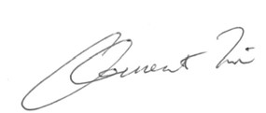
Clement Li
General Manager
Management Consulting Division
Hong Kong Productivity Council
20 April 2018

核實聲明

現代貨箱碼頭有限公司（「現代貨箱碼頭」）按照全球報告倡議組織（GRI）G4 可持續發展報告指引，編寫現代貨箱碼頭可持續發展報告 2015-2017（以下簡稱為「報告」）。香港生產力促進局（「生產力局」）獲現代貨箱碼頭委託，對其報告的內容進行獨立核實。報告涵蓋現代貨箱碼頭由 2015 年 7 月 1 日至 2017 年
12 月 31 日期間，於環境、社會及經濟方面的可持續發展表現。

目標

生產力局進行核實工作的主要目標，是對報告所載資料的完整性、準確性及可靠性進行獨立的評核，具體而言是要：
- 評核報告的內容範圍是否涵蓋所有與現代貨箱碼頭可持續發展表現有關的重要範疇；
- 查核報告是否符合 GRI G4 可持續發展報告指引的核心選項要求；
- 評定報告內被選取出來作查核的陳述及數據是否準確；
- 檢討用以編製報告的數據收集及資料管理機制是否可靠；及
- 為日後的報告提供建議。

方法

生產力局的核實過程是參考 ISAE 3000 標準而進行，程序包括全面審閱報告的內容，然後就現代貨箱碼頭的重要範疇選取具代表性的陳述和數據進行核實。透過 2018 年 4 月 4 日與現代貨箱碼頭的代表會面，我們審閱和檢查了數據整理系統與所選取陳述和數據有關的證明文件，以及現代貨箱碼頭的相關管理規範和措施。

總結

報告整體而言符合 GRI G4 可持續發展報告指引的核心選項要求，並概述了現代貨箱碼頭於其主要服務、活動及工作的環境、社會及經濟方面的表現。就報告的準確性及可靠性而言，核實過程中所選取作檢查的陳述和數據與所審查的源頭資料一致，且公正地反映現代貨箱碼頭在環境、社會及經濟方面的表現。為編寫報告所採用的數據整理和資料管理系統整體而言是可靠的。

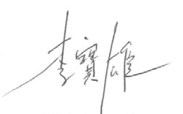
香港生產力促進局
管理諮詢部
總經理
李寶雄
2018 年 4 月 20 日

Modern Terminals Limited
現代貨箱碼頭有限公司
Berth One, Kwai Chung, Hong Kong
香港葵涌一號碼頭
Tel 電話：(852)2115 3838 Fax 傳真：(852)2115 4848
E-mail 電郵：cad@modernterminals.com
www.modernterminals.com

This verification statement has been prepared for Modern Terminals for the purpose of assuring the statements and data presented in its Sustainability Report 2015-2017 only. The statement was prepared based on HKPC’s review of information provided by Modern Terminals during the verification process. HKPC will not accept or assume any responsibility or liability (legal or otherwise) in relation to this verification statement.
Our verification work did not cover data and information which had already been published in the press releases, on the Company’s website, in the annual reports of its mother company or other publications.
此核實聲明的目的，僅作為對現代貨箱碼頭可持續發展報告 2015-2017 內的陳述及數據進行核實用途。此聲明乃基於現代貨箱碼頭提供予生產力局的相關資料，經過審核而得出的結論。生產力局並不負有或承擔任何對於此聲明有關的法律或其他責任。
生產力局的工作不包括核實已於現代貨箱碼頭發布的新聞稿、公司的網站、母公司年報，以及其他公開刊物內載述的數據及資料。

